Department of Agriculture
Rural Housing Service
Rural Community Development Initiative

Southern Vermont Economy Project

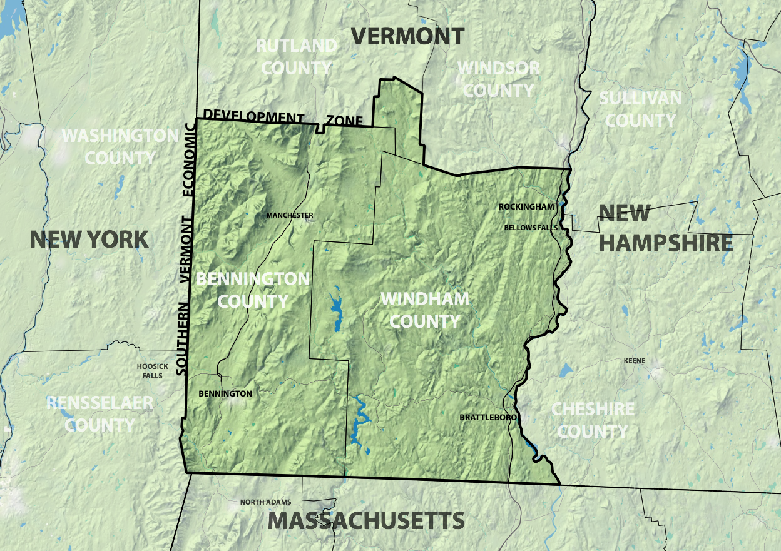
Southern Vermont Economic Development Zone, Map Courtesy of Bennington County Regional Commission

Rural Community Development Initiative

Southern Vermont Economy Project
SUBMITTED BY:
Brattleboro Development Credit Corporation
76 Cotton Mill Hill
Brattleboro, VT 05301
802-257-7731 tel.
802-257-0294 fax

CONTACT PERSON:
Adam Grinold, Executive Director
Email: agrinold@brattleborodevelopment.com

DUNS NUMBER: 1349470190000
CCR: VT-A11
COUNTY WHERE APPLICANT IS LOCATED: Windham County

AREA TO BE SERVED: Southern Vermont Economic Development Zone recently created by an act of the Vermont Legislature, encompassing the Windham and Bennington Regions. This project will build capacity within organizations serving these Regions, two of the most disadvantaged areas of the state. This project will primarily target recipients serving the following 11 towns where population size, household income and poverty create the greatest challenges: In the Bennington Region these are Rupert, Peru, Searsburg, Readsboro and Bennington; In the Windham Region these are Rockingham, Bellows Falls, Wardsboro, Marlboro, Halifax and Brattleboro. Please refer to the project area map provided in the appendix.
AMOUNT OF GRANT REQUEST: $230,000
NUMBER OF RECIPIENTS: 12

Summary Page
The Brattleboro Economic Development Corporation (BDCC) is requesting $230,000 from the USDA Rural Community Development Initiative for the Southern Vermont Economy Project, to be used over two years. The project will develop regional capacity to support economic development across Windham and Bennington counties, building on a successful collaboration formed as the region struggled to recover from the devastating effects of Tropical Storm Irene in 2011. The project goal is to improve capacity within twelve recipient organizations serving some of the counties’ most challenged small towns, so that these organizations can better organize local or regional economic development planning and projects and assist these communities more effectively. The project specifically targets 11 communities with the highest need based on population, median household wage and poverty.
The applicant and Intermediary is the Brattleboro Development Credit Corporation (BDCC). The recipients are qualified public, private and nonprofit community development organizations serving low-income rural communities in the Windham and Bennington Regions. The bulk of funding will be used to hire 1 FTE, and to deploy staff and consultants within qualified community and economic development organizations throughout Southern Vermont. The new personnel placed will conduct trainings and will work with the qualified Southern Vermont recipients to improve coordination and delivery of technical services to improve the effectiveness of economic development activity and outcomes. This includes workforce training, promotion and recruitment, business development, business finance and access to capital.
The goal is improve economic development capacity across the entire “Southern Vermont Economic Development Zone” by creating a new position solely dedicated to this work in order to overcome two major challenges: 1. Uneven support for economic development, which leads to multiple local organizations supporting some towns, and almost no support in others; and 2. duplication or weak coordination and promotion of region-wide programs for business and workforce development. Through this work we intend to create a network of organizations capable of developing a two-county Southern Vermont Comprehensive Economic Development Strategy (CEDS) and establishing a federally recognized economic development district in order to more effectively coordinate and implement regional workforce and business development efforts across both counties.
The timing of this project is critical. First, BDCC currently has state funding to leverage as a match. Second, BDCC is a named participant in the Southern Vermont Economic Development Zone codified by the Vermont legislature in May 2015. The first meeting of the Zone steering committee took place August 6th. BDCC and the Southeastern Vermont Economic Development Strategies (SeVEDS) are regional leaders having produced an EDA CEDS for the Windham Region that has been recognized by the federal government for its excellence. Their successful, ongoing economic planning efforts are stimulating new opportunities for effective action and collaboration across all of Southern Vermont. This includes the possibility that, based on distress criteria emerging in the regions, the Economic Development Administration may designate a federally recognized Economic Development District (EDD). The RCDI project would pave the way for creating a two region CEDS, a pre-requisite to establish the EDD and with it the guaranteed annual EDA funding annually to implement an economic development action plan.
Table of Contents

Southern Vermont Economy Project 1
Summary Page 2
Project Overview 4
Project Activities 6
Evaluation Criteria 9
Building Capacity and Expertise 9
Type of assistance 9
Project goals 9
How will capacity be improved 10
Timetable with Detail of Technical Assistance Activities 11
Timetable continued 12
Timetable continued 13
Benchmarks: Building Capacity and the Capacity to Measure Effectiveness 14
Baseline, Quarterly, Annual and Final assessments to guide and evaluate the project 15
Beneficiary Communities: Population, Income, Poverty 17
Table Showing Recipients Physically Located in Qualifying Areas 17
Map of Distressed Communities in Windham and Bennington Regions 19
Track Record 22
Matching Funds 23
Shared Challenges and Regional Leadership 23
Complete Table of Recipients: Southern Vermont Economy Project 25
Budget 27
Use of RCDI Funds 27
Complementarity: WCEDP & RCDI Funded Work 28
Appendices: Table of Contents 29

Project Overview

The Southern Vermont Economy Project will develop regional capacity to support economic development across Windham and Bennington counties. This project builds on a successful collaboration formed as the region struggled to recover from the devastating effects of Tropical Storm Irene, which wiped out infrastructure, downtowns and small businesses in communities that continue to struggle even today. The project aims to improve capacity within recipient organizations serving some of the Southern Vermont region’s most challenged small towns, so they are able to better organize locally or regionally (as appropriate) to undertake economic development projects assist these communities more effectively. The applicant and Intermediary is the Brattleboro Development Credit Corporation (BDCC) a Vermont Regional Development Corporation serving the Windham Region. The recipients are twelve qualified public, private and nonprofit community development organizations serving low-income rural communities. Some work at the local level, others provide region-wide support as well.
BDCC is requesting $230,000 from the USDA Rural Community Development Initiative for the Southern Vermont Economy Project, to be used over two years. The goal is to improve economic development by building capacity within twelve recipient organizations serving the region’s most challenged towns, to improve their ability to act locally and collaborate regionally, to undertake economic development planning and projects. The project will improve regional capacity to support economic development across the Windham and Bennington Regions by building capacity within recipient organizations serving Southern Vermont, one Vermont’s most disadvantaged Regions. It builds on a successful collaboration formed as the region struggled to recover from the devastating effects of Tropical Storm Irene.
The applicant and Intermediary is the Brattleboro Development Credit Corporation (BDCC). The recipients were carefully selected because they serve the region’s most challenged communities. The recipients are qualified public, private and nonprofit community development organizations serving low-income rural communities within the Windham and Bennington Regions. The project specifically targets communities with the highest need based on population, median household wage and poverty. In the Bennington Region these are the towns of Rupert, Peru, Searsburg, Readsboro and Bennington; In Windham these are Rockingham, Bellows Falls, Wardsboro, Marlboro, Halifax and Brattleboro. A project area map showing town locations is provided in the “Evaluation Criteria” section of this application.
The bulk of funding will be used to hire 1 full time employee (FTE) and to deploy staff and consultants within qualified community and economic development organizations throughout Southern Vermont. The new personnel put in place will conduct trainings and will work with the qualified Southern Vermont recipients to improve coordination and delivery of technical services to improve economic development activity and outcomes. This includes workforce training, promotion and recruitment, business development, business finance and access to capital.
With a new position solely dedicated to this work we can begin to overcome two major challenges undermining the effectiveness of existing economic development efforts:
- Uneven support for economic development, which leads to multiple local organizations supporting some towns, and almost no support in others; and
- Duplication or weak coordination and promotion of region-wide programs for business and workforce development. Through this work we intend to create a network of organization capable of developing a two-county Southern Vermont CEDS and establishing a federally recognized economic development district in order to coordinate regional workforce development efforts across both counties.
The timing of this project is critical. First, BDCC currently has the ability to leverage state funding as a match. Second, BDCC is a named participant in the Southern Vermont Economic Development Zone created by the Vermont legislature. The first meeting of its steering committee took place just 2 weeks ago. Third, BDCC and SeVEDS bring recognized leadership that produced a CEDS for the Windham Region, one that has been recognized for its excellence. This successful, ongoing effort is stimulating new opportunities to collaborate for better effect and scale across all of Southern Vermont. These opportunities include the possibility that, based on distress criteria emerging in Windham and Bennington regions, the Economic Development Administration may designate a federally recognized Economic Development District (EDD). This project would pave the way for Bennington and Windham to create a two region CEDS, a pre-requisite for obtaining the EDD and with it the guaranteed annual EDA funding to implement an economic development action plan.
BDCC will use the $230,000 in matching funds from the State of Vermont Windham County Economic Development Program, available beginning fall 2015, to conduct related economic development capacity-building activities. The state funds will be used to hire a staff person this fall for a position dedicated to working directly with businesses and potential entrepreneurs. Funding from RCDI will enable the twelve Recipient Organizations to act in parallel with the state-funded efforts, building capacity in organizations that work with local communities and people to attract, and to support new and growing businesses and develop the regional workforce. Together, the suite of activities made possible by RCDI and state support will improve the ability of individual communities and the entire region to increase economic activity, better support existing businesses, stimulate demand, attract customers, retain and expand workforce, and improve household wages.
The new personnel placed within recipient SeVEDS will conduct trainings for local individuals, businesses and organizations. They will work with the other recipients, local and regional organizations, to improve coordination and delivery of technical services to support economic development activity. The goal is to improve economic development capacity across the entire “Southern Vermont Economic Development Zone” by creating a new position solely dedicated to this work in order to overcome our two major challenges: Uneven support for economic development which leads to multiple local organizations supporting some towns, and almost no support in others; and duplication or weak coordination of region wide programs for business and workforce development.

Project Activities
The Southern Vermont Economic Development Zone was formed by the Vermont legislature in 2015 in response to persistent economic challenges across the Windham and Bennington Regions. However, the Zone has no budget and there is no existing capacity at the scale of the entire region. This means areas that are currently under-served for economic development are now better recognized, but not better resourced. Funding for the Southern Vermont Economy Project will enable BDCC to provide technical and financial assistance over two years, to improve the capacity of local organizations to undertake economic development projects in the region’s most economically challenged communities, and across all of Southern Vermont. The Project will use funds to develop capacity within twelve recipient organizations, details of which are provided in the “Evaluation Criteria” section of this application.
In order to build on the Vermont Legislature’s brand new Zone designation while momentum is strong, BDCC has taken the lead in submitting this application. Interest is high, and there is some economic development capacity and expertise already here. There are dozens of disparate organizations serving individual municipalities, sub-regions or specific sectors like tourism, culture or food. There is region-wide capacity in the RDCs and RPCs. However, with few exceptions, most of the region’s small, rural towns and villages have no local capacity for economic development. As with the post-Irene recovery efforts, we know that dedicated personnel and targeted activities on the ground are critical to obtaining positive results.
By creating a full time position within SeVEDS, BDCC will provide and procure technical assistance for the project’s economic development activity across Southern Vermont. They will lead a collective needs assessment with the recipient organizations, and facilitate trainings and workshops to increase staff and organizational capacity for economic development programming to serve the hardest hit communities. In the near term the goal is to increase recipient capacity to pursue economic development projects. Please refer to the Timetable in the “Evaluation Criteria” section of this application for further detail and completion schedule for activities. The overarching goal is to improve coordination of existing resources, to identify gaps, reduce competition and improve collaboration among the twelve priority organizations conducting economic development in the two counties, in order to prepare for the creation of a region-wide economic development plan in the next five years.
Building Capacity. To better serve beneficiary communities in the near term, this project must improve the quantity, coordination and effectiveness of economic development programs. The project will secure technical assistance to develop the recipients’ capacity to meet the following objectives:
- Develop new economic development expertise and knowledge among existing staff.
- Design specific new programs for recipients to deliver in order to expand their capacity to assist high-need communities. This will improve capacity parity across the Zone, and improve these communities’ ability to access other regional, state and federal programs.
- Provide technical assistance and funding to coordinate existing, disparate organizations engaged in economic development and improve communities’ access to these resources. This includes regional and local economic development organizations, a range of town governments, downtown organizations, chambers of commerce and other community-based enterprises. This includes better defining local vs. regional roles and responsibilities in economic development.
- Work with the new Zone Committee to leverage regional initiatives and access resources for new capacity building. The committee is charged with implementing the Southern Vermont Sustainable Marketing project, and assessing connections of local internship, young professional and workforce programs to improve the overall workforce quality and supply.
Building Expertise. The Southern Vermont Economic Development Project will work across sectors, supporting economic development activities to improve the quality of life for our rural communities by focusing on outcomes such as increased year round employment, better wages, career paths for young people, and workforce supply so local businesses can thrive here. Technical assistance will be targeted to improve recipient expertise in workforce and business development programs for local residents and employers. Specific training will also be targeted to improve knowledge of, and ability to access specialized resources targeted to key local sectors: Green Building, Tourism and the Arts, Healthcare and technology driven precision manufacturing. This region not only has robust opportunities in these sectors, existing businesses are struggling to fill positions, placing firms at risk of failure or relocation.
Local and Regional Activities. In addition to organizational and program development, the Southern Vermont Economy Project will provide assistance for recipients to conduct activities in three areas:
- Local: Targeted community based trainings in Economic Development practices to enable individual towns to plan and execute critical projects. Ongoing assistance to communities, deploying new recipient expertise on the ground. This expands existing functions.
- Regional: Coordinated delivery of services, to reduce redundancy and assess resource gaps. Using successful models from tourism-based regional collaborations recipients will build shared capacity for economic development. This will make existing functions more effective.
- Regional - Internal: A framework to coordinate across recipient organizations will be developed to improve service delivery to beneficiary communities, and enable new region-wide economic development initiatives. This will be a new function for recipients.
Community Outreach. To encourage use of the Technical Assistance Programs outreach will include:
- Southern Vermont Economy Project Promotional Flyer delivered to target communities’ elected officials, and public notice pathways.
- Southern Vermont Economy Project web presence on home page of each recipient organization.
- Recipient presentation to Town Selectboard, Meeting, Planning Board or other similar body.
- Radio and newspaper interviews and press releases.
- Public meeting conducted by recipient organization(s) serving target communities.
Opportunity and Urgency. The Southern Vermont Economic Development Zone currently has no capacity at the scale of the RPC and RDC: Windham and Bennington Counties and several additional towns included in the agency service areas. Funding for the Southern Vermont Economy Project will enable BDCC to create a full time position within SeVEDS, and augmented staff and consultant capacity within twelve recipient organizations with a wide range of experience, relationships and existing capacity. The project will help BDCC provide technical assistance dedicated to economic development in the region’s most economic challenged communities, and across the region, in order to create new opportunities to improve quality of life for the people of Southern Vermont.

Timetable - Abbreviated
The Southern Vermont Economy Project will last for two years. In Year 1 RCDI funded work will involve a series of hiring, information-gathering and collaboration-building activities in the first year. In Year 2 it will focus on routines and responsiveness, based on activities from Year 1.
A complete and detailed list of activities and accompanying timeline are included in the “Evaluation Criteria” Section of this application. That timetable covers initial launch through at the start Year 1, through Project Implementation in Year 2. It itemizes project activities, timeframe to completion, outputs, anticipated hours required, and outcomes.
The following abbreviated timetable summarizes project activities in Years 1 and 2.
Year 1: Launch and Baseline

Activity | Completion Date | Outputs
BDCC hires SVEDP | First 30 days
Organizational Outreach and Familiarization: | 2-4 months | Data and Assessment
Organizational Benchmarking and Discovery | 4-6 months | Workshops: Skills Development & Discovery
Development of shared goals and projects | 6-12 months | Workshops, Project Development
Year 2: Local Projects and Regional Collaboration

Project Refinement, Development and Public Outreach | 12-18 months | Community Outreach
Project Refinement, Development and Public Outreach | 12-24 months | Project Development and Implementation

Evaluation Criteria

Building Capacity and Expertise

The Brattleboro Economic Development Corporation (BDCC) is will use USDA Rural Community Development Initiative funding to launch the Southern Vermont Economy Project, to be executed over two years. The project will develop regional capacity to support economic development across Windham and Bennington counties, building on a successful collaboration formed as the region struggled to recover from the devastating effects of Tropical Storm Irene. The project specifically targets 11 high-need communities, based on low population and median household wage.

Type of assistance
Funding will be used to hire one (1) FTE, and to deploy staff and consultants within qualified community and economic development organizations throughout Southern Vermont. The new personnel placed will conduct trainings and will work with the qualified Southern Vermont recipients to improve coordination and delivery of technical services to improve economic development activity and outcomes. This includes workforce training, promotion and recruitment, business development, business finance and access to capital. Please see the Timetable for detailed overview of activities.

Project goals
The project goal is to improve the capacity for conducting economic development projects within twelve recipient organizations serving some of the counties’ most challenged villages and towns. Through workshops, trainings, project development and focused collaborations, recipient organizations will increase staff skills, improve awareness of regional resources, improve their outreach and effectiveness, and improve overall effectiveness by reducing overlap between agencies and improving coordination.
At the end of the two years, recipients will be able to better organize locally or regionally (as appropriate) to undertake economic development planning and projects. The recipients are qualified public, private and nonprofit community development organizations serving low-income rural communities in the Windham and Bennington Regions.
The desired outcomes are to improve economic development capacity across the entire “Southern Vermont Economic Development Zone” by creating a new position solely dedicated to this work in order to overcome two major challenges: 1. Uneven support for economic development which leads to multiple local organizations supporting some towns, and almost no support in others; and 2. Duplication or weak coordination and promotion of region-wide programs for business and workforce development. Through this work we intend to create a network of organization capable of developing a two-county Southern Vermont CEDS and establishing a federally recognized economic development district in order to coordinate regional workforce development efforts across both counties.

How will capacity be improved
BDCC is leveraging state funding as a match for a total project budget of $460,000. It will be used to stimulate new opportunities and collaborations to pave the way for creating a two region CEDS and the possibility of becoming an EDA recognized Economic Development District (EDD), and establishing an annual revenue stream to implement a regional economic development action plan.
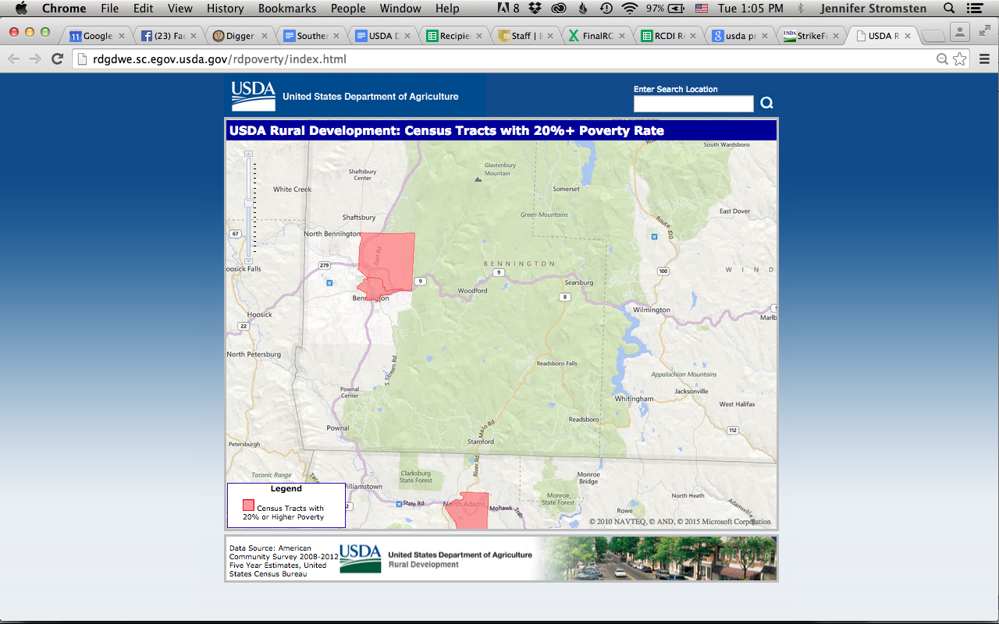
The Southern Vermont Economic Development Zone recently codified by an act of the Vermont Legislature encompasses the Windham and Bennington Regions. In the absence of County Government, the service area is defined as those communities served by the regional planning commission and regional development corporations; Windham Regional Commission and Brattleboro Development Credit Corporation in the southeast, Bennington Regional Commission and the Bennington County Industrial Corporation. The legislature created this new Southern Vermont Economic Development Zone encompassing these areas in response to the region’s ongoing challenges: aging population, slow job growth, weak workforce, low wages and poverty. A copy of the Southern Vermont Economic Development Zone (included in S138, 2015 Legislative Session) is included within this package. Passage of this act acknowledged this region’s need for greater commitment of resources to produce results. However, the state budget faced serious cuts this year and the act came without funding. RCDI funding will enable the region leverage political momentum, existing assets and funding to promote economic development at this critical time.
Screen Shot from USDA Web Site Promise Zone Map Showing Bennington's 2 Qualifying Tracts
Bennington and Brattleboro are rural service centers for this region, where many of the region’s most disadvantaged residents are concentrated. Both have census tracts showing highly concentrated poverty. Bennington has two census tracts with over 20% poverty, forming a USDA qualified “Promise Zone”. In addition, poverty rates for the population under 18 are at 23.1% in Bennington County and 15.7% in Windham County, with some census tracts over 20% in the Town of Bennington and even higher poverty rates among minors. The Bennington and Windham regional organizations involved in this project provide most of the community and economic development capacity targeted to these distressed areas.

Timetable with Detail of Technical Assistance Activities

The Southern Vermont Economy Project will last for two years. RCDI funded activities will involve a series of hiring, information-gathering and collaboration-building activities in the first year. In Year 2 the project will focus on routines and responsiveness, building on Year 1. The following tables provide detail on project activities, timeframe to completion, outputs, anticipated hours required, and outcomes.
Activity | Completion Date | Outputs | Total hours of recipient time required | Outcomes
Year 1: Launch and Baseline
BDCC hires SVEDP | First 30 days | Four recipient organizations screen preliminary applications, develop first round interview questions, recommend up to four candidates | 16 | SVEPD hired with initial buy in from recipients. Utilize input from representative group in hiring process, and the  establishment of a sub-committee for future sub-projects, if needed
Organizational Outreach and Familiarization: | 2-4 months | Data Collection: Spend one week with each priority recipient organization observing | 66 | Catalogue of existing Southern Vermont economic development services, organizational priorities, goals, and needs
 | 2-4 months | Data Collection: Human and financial resources availability | 66
 | 2-4 months | Data collection: Internal Metrics and Goals - who is being served? | 66
 | 2-4 months | Assess: Existing communication means | 66
 | 2-4 months | Assess: Existing business development and assistance programs | 66
 | 2-4 months | Data Collection: Board Interviews - Threats and Challenges | 66
 | 2-4 months | Review: Existing Organizational Documents (bylaws etc) | 66
 | 2-4 months | Review: Existing Goal and Planning documents | 66
 | 2-4 months | Review: Projects completed in past 5 years | 66

Timetable continued
Activity | Completion Date | Outputs | Total hours of recipient time required | Outcomes
Year 1: Launch and Baseline Continued…
Organizational Benchmarking and Discovery | 4-6 months | Workshop: Rules of Engagement and Digital Collaboration | 90 | Southern Vermont Economic Development Recipients gain understanding of existing economic development activities
 | 4-6 months | Benchmarking Workshop: Southern Vermont  Economic Development Entities - Capacity and structure, Communication Efforts and Audiences | 90
 | 4-6 months | Discovery Workshop: Existing Southern Vermont  Business Development and Assistance Programs | 90
 | 4-6 months | Discovery Workshop: Duplication of Effort and Repitious Challenges in Southern Vermont | 90
 | 4-6 months | Discovery Workshop: Major Projects Completed and Underway | 90
Development of shared goals and projects | 6-12 months | Workshop: Southern Vermont population and workforce data review and goal setting | 90 | Agreed upon list of goals and projects to be acted on in Year 2
 | 6-12 months | Workshop: Southern Vermont employment sector and job data review and goal setting | 90
 | 6-12 months | Workshop: Southern Vermont housing and transportation data review and goal setting | 90
 | 6-12 months | Workshop: Southern Vermont education and quality of life data review and goal setting | 90
 | 6-12 months | Workshops: Project Development | 90
 | 6-12 months | Workshop: Project Development | 90
 | 6-12 months | Workshops: Project Development | 90
 | 6-12 months | Workshop: Project Development | 90

Timetable continued
Activity | Completion Date | Outputs | Total hours of recipient time required | Outcomes
Year 2: Local Projects, Regional Collaborations
Project Refinement, Development and Public Outreach | 12-18 months | Business and Community Outreach Region-wide | 185 | Business leaders and communities throughout Southern Vermont and the State of Vermont have refined projects. Multiple short and long term projects to improve the economy are underway in Southern Vermont. Partners have agreed upon a pathway to continue working together through the year 2026.
 | 12-18 months | Project refinement implementation and resource development | 185
 | 12-18 months | Business and Community Outreach Region-wide | 185
 | 12-18 months | Project refinement, implementation and resource development | 185
 | 18-24 months | Southern Vermont in 2026 | 185
 | 18-24 months | Project implementation and resource development | 185
 | 18-24 months | Southern Vermont in 2026 | 185
 | 18-24 months | Project implementation and resource development | 185
 | Total |  | 3075

Benchmarks: Building Capacity and the Capacity to Measure Effectiveness

The actions outlined in this proposal are part of a coordinated effort to expand capacity for economic development within organizations and communities across the region, in a collaborative manner. Multiple studies, reports and plans seeking to improve the economic climate of Southern Vermont have articulated the needs: from the FEMA Long Term Recovery report done in 2012 to the Windham CEDS. A more recent study by the University of Massachusetts Donahue Institute details economic impacts in the region due to the closure of the Vermont Yankee Nuclear Power Station (near Brattleboro). Last month another major closure was announced: Plassan manufacturing in Bennington is moving hundreds of high wage jobs to Michigan. Even without a new study we know this is devastating.
The design, timeline and goals of the Southern Vermont Economy Project leverages resources and builds upon increasing stakeholder commitment to economic development, as people realize the recession has simply not ended in this region. Vermont’s recovery overall masks an underlying reality that the Burlington region to the northwest is moving ahead while the rest of the state is left behind. In the broadest sense, this project’s effectiveness will be based on its contribution to broader, long-term efforts to catch up.
As a standalone effort, this project must be effective on two basic levels – local and regional. At the end of the project we need to know if the most disadvantaged towns are better-served by recipient organizations based on their improved capacity. As a result of that improvement, can we see or anticipate new economic activity that will improve quality of life for the region? Above all, at the end of the project, is Southern Vermont ready to launch a region-wide collaboration to study, plan and execute economic development?
Procedures to measure effectiveness will be an integral part of capacity-building among recipients. Evaluation of the project will be carefully conducted throughout the duration of the project and for a two-year period after project implementation is complete. Therefore, a central element of the technical assistance to be provided will be around metrics for evaluation, program design and goal-setting. By agreeing upon a set of shared benchmarks at the outset, the framework for collaboration will be established. Evaluations will be conducted jointly to ensure coordination, and improve capacity among recipients for using metrics in their economic development work. Clear objectives and targets have been extremely successful in executing the Windham Region S.M.A.R.T. CEDS.

Baseline, Quarterly, Annual and Final assessments to guide and evaluate the project

I. Baseline: In the first month of the project BDCC will collect detailed data for recipients to use in establishing benchmarks to measure where we are, so we can determine the impact of the Southern Vermont Economy Project within target communities over time.
    - Census data and demographics*
    - Available economic data and related studies: GDP, jobs, employers*
    - Overview of formal and informal orgs involved in local economic development

In months 2-4, BDCC will work with recipients to catalogue of existing Southern Vermont economic development services, organizational priorities, goals, and needs. Data will be collected on human and financial resources available as well as internal metrics and goals, and establishing who is being served. Board members from the priority recipients will be interviewed on existing threats and challenges to their organization. BDCC will assess existing communication means and audiences as well as business development and assistance programs specifically looking for opportunities for recipients to build increased effectiveness in delivery of services and execution of programs. A review of organizational documents, goal and planning reports and major projects completed in the past five years will be conducted to more accurately assess opportunities to establish regional best practices and collaboration.

Recipients will use this information to outline program goals and objectives for target areas. The baseline data will be revisited annually during project implementation and for a two year period afterwards. Given the short timeframe and challenges of data collection in small, rural places, it may be difficult to judge progress in the near term using this data. However, this baseline is needed for a region-wide plan, and to build consensus around core objectives.

II. Quarterly evaluations: To assess the effectiveness of each individual component of this project, we will conduct quarterly evaluations with all recipient organizations in the areas outlined below, with an asterisk to indicate where quantitative assessment is possible. Ongoing assessment will allow us to adjust strategy during implementation to secure additional help.

- Trainings for Recipients
  - Hours of training undergone by recipient organization staff*
  - Areas of expertise developed
  - Service gaps identified and addressed
- Recipient Outreach to Beneficiaries
  - Recipient execution of outreach in target communities (flyer, web, town presentation)*
  - Response or activity generated (inquiries, invitations, assistance sought)*
- Economic Development Capacity among Recipients:
  - New or expanded initiatives in individual recipient organizations, due to this project
  - New skills or programs the recipient can now offer

The Southern Vermont Project will improve recipient’s ability to help communities engage in economic development, and to respond to specific needs that arise from that engagement. Quarterly evaluation of recipient activity is part of capacity-building, as recipients learn together how to evaluate and improve and seek opportunities to collaborate.

III. Annual Evaluation of the Project: We will conduct an annual review of the activities outlined above. These evaluations will themselves be part of the technical assistance, an opportunity to build capacity in program-development and execution in recipient organizations. These evaluations will look backwards at activity effectiveness, and the results used to create action plans. They will also incorporate anecdotal data, to supplement information on measurable actions and limited data available.

  - Did recipient outreach activities lead to further engagement with communities? Description and documentation? (event brochures, newspaper articles, letters)
  - Did training or follow-on activity result in new or expanded capacity for beneficiaries? (for example an Economic Development committee formed or town seeking project funds)
  - Did this activity result in new or expanded business activity? To include documentation (interview notes, newspaper articles, letters from business or municipality).
  - Was there demand for services recipient organizations could not provide, either due to expertise or staffing constraints?
  - What new projects or initiatives are available going forward as a result of recipient cooperation?
  - Document new practices as a result of this project: in recipients, collaborative, or region-wide. (for example benchmarking, a regional coordinating committee for economic development)
  - Findings and next steps: Program gaps, additional capacity needs, new projects.

III. Final Evaluation: Regional Economic Development Capacity Building
Annual evaluation questions above will be used both at the end of year one, and at the end of the two year project cycle. While the purpose of the RCDI capacity building work is to improve Quality of life, the data points are difficult to measure in just two years, at such small scale. Therefore, the baseline data established at the outset will be revisited in light of that program evaluation information described above, in order to conduct a final assessment that connects the project’s activities with its goals.

  - Services, programs, expertise available due to recipient capacity building (new and expanded)
  - Activities conducted in target communities (quantitative and descriptive overview)
  - Activities conducted region-wide (quantitative and descriptive overview)
  - Going forward, how recipients will direct new capacity towards reducing poverty, reversing population loss among younger cohorts, and raising median household income.

Evaluations and findings will be compiled in a detailed final report.

Upon completion of the proposed project, the region will benefit from the following results:

- New and improved capacity in at least 12 recipient organizations offering critical economic development support to communities in need.
- New and augmented economic activity in target communities and across the region.
- Improved understanding of local and regional needs, useful to design new initiatives.
- Better coordination and effective deployment of resources to promote economic development.
- New Region-wide capacity to support the Southern Vermont Economic Development Zone.

This work is part of a long-term effort to create prosperity for Southern Vermont’s rural communities so they can be self-sustaining, re-populating, and economically thriving (USDA Strategic Goals).

Beneficiary Communities: Population, Income, Poverty

The Southern Vermont Economy Project will build capacity within twelve (12) recipient organizations serving southern Vermont. The project area encompasses two of the most disadvantaged areas of the state, the Windham and Bennington Regions. The Project specifically targets eleven (11) communities with the highest need based on population, median household wage and poverty: In the Bennington Region these are Rupert, Peru, Searsburg, Readsboro and Bennington; In Windham they are Rockingham, Bellows Falls, Wardsboro, Marlboro, Halifax and Brattleboro. Recipients involved were selected because they serve these towns, some by working region-wide.
The table below lists just the recipient organizations physically located in areas that correlate with qualifying evaluation criteria for community need: low population size and very low median household income. A complete listing of recipients is found later in the “Project Recipient” section.

Table Showing Recipients Physically Located in Qualifying Areas
RECIPIENT | PHYSICAL ADDRESS | GEOGRAPHY | POPULATION | MEDIAN HH INCOME | PCT OF VT MHI | MHI X POP
Bellows Falls Area Development Corp. | 25 Square, Bellows Falls, VT | Census Tract 9670, Windham Co, VT | 3251 | $31,960 | 62% | $103,901,960
Bellows Falls Downtown Development Alliance | 24 Square, Bellows Falls, VT | Census Tract 9670, Windham Co, VT | 3251 | $31,960 | 62% | $103,901,960
Great Falls Chamber of Commerce | 7 Westminster St, Bellows Falls, VT | Census Tract 9670, Windham Co, VT | 3251 | $31,960 | 62% | $103,901,960
Brattleboro Area Chamber of Commerce | 180 Main Street, Brattleboro, VT | Census Tract 9685, Windham Co, VT | 5807 | $35,672 | 69% | $207,147,304
SeVEDS | 76 Cotton Mill Hill Brattleboro, VT | Census Tract 9685, Windham Co, VT | 5807 | $35,672 | 69% | $207,147,304
Strolling of the Heifers | 157 Main St, Brattleboro, VT | Census Tract 9685, Windham Co, VT | 5807 | $35,672 | 69% | $207,147,304
Windham Regional Commission | 139 Main Street, Brattleboro, VT | Census Tract 9685, Windham Co, VT | 5807 | $35,672 | 69% | $207,147,304
Bennington County Industrial Corp. | 215 South St, Bennington, VT | Census Tract 9712, Bennington Co, VT | 5073 | $30,671 | 59% | $155,593,983
Bennington County Regional Commission | 111 South St, Bennington, VT | Census Tract 9712, Bennington Co, VT | 5073 | $30,671 | 59% | $155,593,983
Better Bennington Corporation | 215 South St, Bennington, VT | Census Tract 9712, Bennington Co, VT | 5073 | $30,671 | 59% | $155,593,983
Town of Bennington | 205 South St, Bennington, VT | Census Tract 9712, Bennington Co, VT | 5073 | $30,671 | 59% | $155,593,983
Readsboro Hometown Redevelopment Corp. | 7012 Main St, Readsboro, VT | Readsboro Town, Bennington Co, VT | 763 | $37,578 | 72% | $ 28,672,014
PRORATED MHI FOR SERVICE AREA |  | $33,150.92
PERCENT OF 2010 US MHI ($51,914) |  | 63.95%
AVERAGE POPULATION PER RECIPIENT |  | 4503
POPULATION POINTS |  | 5
MHI POINTS |  | 10

The Southern Vermont Economy Project is designed to address a fundamental capacity problem - gaps in service area. This application cannot build capacity in recipients located within every town with high need, because there simply are not qualified partners in each location. This project is meant to begin filling those gaps region-wide by developing capacity in local and regional organizations that serve these places, despite being located elsewhere in the region. The project Intermediary BDCC has selected key recipients region-wide organizations SeVEDS, and Bennington Regional Commission and Bennington County Industrial Corporation. These agencies have as their service area every town within their respective regions of Windham and Bennington.
This project’s approach deploys both regional and local organizations to leverage the full range of resources available to reach into our neediest communities. For this reason, in addition to the detail above regarding recipient locations, the map below shows all of the Southern Vermont qualifying communities served by the twelve recipients. New capacity created within recipient organizations will benefit the eleven target communities, as well as communities across the entire region. This project will improve prosperity for rural Southern Vermonters by directing resources into communities most in need, thereby improving the Southern Vermont economy for all.
Every town in the region, aside from the regional service centers Brattleboro and Bennington has a population of fewer than 10,000 people. Many communities have little to no municipal governmental capacity, much less staffing or budget to execute community and economic development activities. This grant’s recipient organizations carry a special burden in trying to serve communities with such limited resources.
A map provided on the following page shows the financial need across the region.

Map of Distressed Communities in Windham and Bennington Regions

The map below shows the entire Southern Vermont Economic Development Zone, as codified by the Vermont Legislature in 2015. This is the region targeted by the Southern Vermont Economy Project, for which USDA RCDI funding is sought, to be matched by Vermont state WCEDP funding.
- Areas labeled 1-4 correspond to geographies noted in the “Table Showing Recipients Physically Located in Qualifying Areas” on page 17.
- Villages and towns in yellow have median household income between 70-80% of Vermont Median Household Income (VMI).
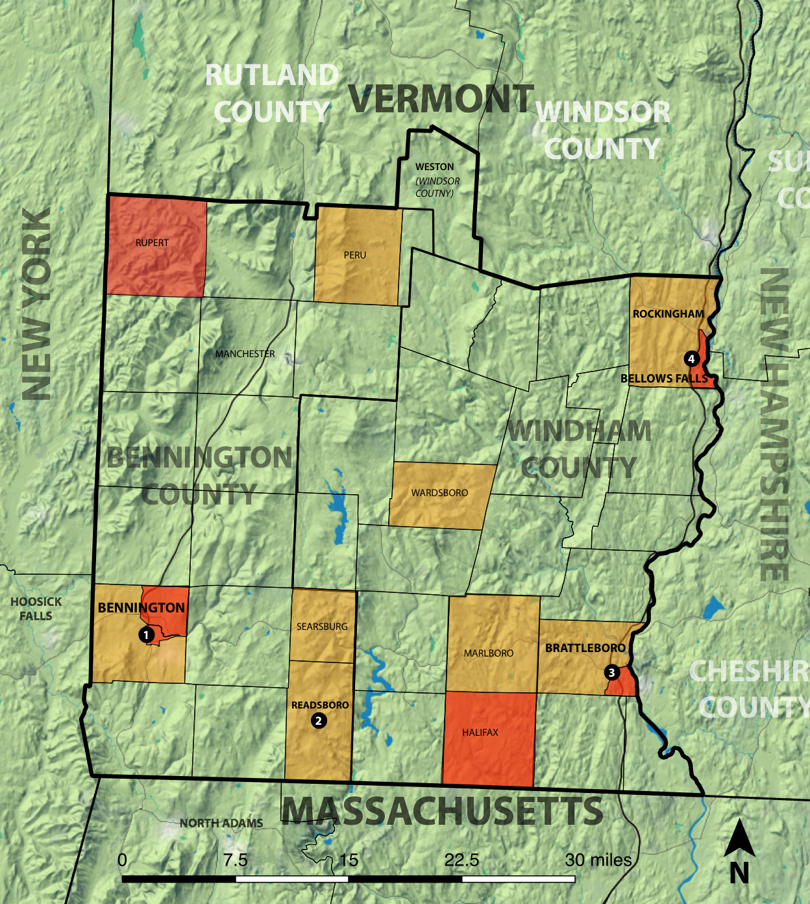
- Areas in red (villages, towns or census tracts) are below 70% of VMI.
Distressed Communities in Southern Vermont, Map Courtesy of Bennington County Regional Commission

Goals and Objectives
The Southern Vermont Economy Project will develop the capacity and ability of non-profit organizations to launch, support and execute projects related to economic development in rural areas. It will provide technical and financial assistance to twelve recipient organizations serving eleven of Southern Vermont’s most challenged rural communities. According to the 2013 American Community Survey, the Southern Vermont Economic Development Zone has a poverty rate of 13%, compared to the state rate of 11.8%. The child poverty rate (under 18 years old) is 19.1%, compared to 14.8% for the state overall.
The Intermediary, Brattleboro Development Credit Corporation, will help to improve the quality of life for the region’s poor and low-wage households by targeting resources to areas where capacity is most needed.
This project is part of a larger effort to help Southern Vermont’s villages and towns create prosperity by extending a highly effective partnership between Windham and Bennington Regions formed in the wake of Tropical Storm Irene the counties delivered critical assistance to villages and towns to retain and regain businesses and residents. With EDA Disaster Recovery funds they placed full time Flood Recovery Officers on the ground and established a regional Business Resource Service Center. This work was critical to business district revitalization. However, some communities, like Rockingham, have not recovered from and need more help. In terms of jobs and economic activity, the region has not recovered from the recession. We need continued and increased efforts to help southern Vermont’s communities become self-sustaining - to attract and retain young people to offset the high proportion of aging residents and support commercial activity communities need to thrive economically.
The Southern Vermont Economic Project has four main programmatic objectives.
OBJECTIVE #1: Establish Capacity to serve the region’s most challenged communities.
This project will provide 1 FTE at recipient SeVEDS, and fund additional staff and consultants operating within recipient organizations serving the most challenged communities. Dedicating support to places with greatest need and lowest capacity will represent a major improvement over the current situation. Recipients will be able to directly act on local projects, and also enhance communities’ own capacity: volunteer and limited professional municipal staff. Additionally, this process will give a voice to these communities, to improve participation in the regional economy and prosperity.

OBJECTIVE #2: Increase staffing capacity to support region-wide economic development.
Improved capacity means additional people, more time dedicated by existing staff. It means improved economic development knowledge and skills within the recipient organizations gained through trainings and the use of expert consultants. RCDI funds will establish region-wide economic development capacity for the Southern Vermont two county Zone, something that has not been available. The Intermediary, BDCC, will provide technical assistance in the fundamentals of economic development: business expansion and retention, workforce training, innovation, catalytic projects and an ecosystem that nurtures entrepreneurs and small businesses region-wide.

OBJECTIVE #3: Improve coordination to better deploy existing and new capacity across the region.
There are dozens of organizations doing economic development work across Southern Vermont, many doing so in isolation. The resulting service is characterized by overlaps and gaps, both in geographic coverage and types of assistance provided. Some are local, some regional, some targeting specific sectors or focused on areas like entrepreneurship or workforce training. The Southern Vermont Project will begin to identify these overlaps and gaps, and to link disparate initiatives into a more focused, coordinate effort in order to leverage investments and energy at this time.

Objective #4: Build regional capacity to execute a two-county economic development strategy.
Improving and increasing capacity is a big part of this. But this project will also provide an opportunity to develop data-driven, long-term goals for a regional effort. In the first 90 days Baseline Information will be established (see Benchmarks section above). This information will be used to formulate long-term goals for improving quality of life in the region. This work will be conducted in accordance with the methodology used in the Windham Regional CEDS, for example:
“Our intent is to secure specific commitments from stakeholders in adopting strategies which can be executed to achieve our stated goals.
- Reverse Population Decline 2009 = 42,605 est.
- 669 new jobs @$ 43,833 and 446 new jobs @$39,848 (NNE Average Wage)
- Improvement of 4,464 jobs by $5,000/yr.
- $69M new wages $141M in new GDP
- Reach Regional GDP of $2.8B
- Increase Median Annual Income for Associates/Some College from $26,855 to $32,000
- Increase Median Annual Income for Bachelor’s Degree from $32,518 to $39,000
- Improve the Ratio of Net Earned Income to Total Income from .566 to .65To End Population decline”
The Southern Vermont Project’s success must be measured in terms of outcomes for individuals and communities. However, an economy is regional: Business and services, workforce development, jobs and spending cross municipal boundaries. Prosperity will result from a balanced effort that can both (a) focus on communities with the highest need, and (b) improve opportunity and economic activity region-wide. Therefore, one of the most important goals of this work will be for BDCC to work with the recipients to help communities recognize their connection to regional and national economies, to form an effective coalition that can work towards goals at multiple scales, involving multiple timeframes.
- Local Activity: Economic Development located in communities.
- Recipient capacity: New skills, initiatives, and ability to support projects in every community.
- Region-wide Collaboration: Reduced duplication and competition, effective action to improve quality of life (poverty reduction, wage improvement, population).

- Near term: Capacity across the Zone (both counties) to access funding for economic development planning and actions region-wide and execute projects.
- Medium term: Capacity to develop a region-wide ED plan, such as an EDA approved CEDs.
- Long term: Sustained commitment, leadership and funding to foster an economically thriving, self-sustaining, growing southern Vermont.
Ability to Provide Technical Assistance
Brattleboro Development Credit Corporation (BDCC) is a Vermont Not for Profit entity. The Corporation is exempt from income taxes under Internal Revenue Code Section 501(c) (6) and similar state statutes. BDCC benefits from a solid employee skill base made up of four (4) full time employees, and three subject to contractual terms and conditions. BDCC is collocated with the Small Business (SBDC) offices.
As the local development corporation, BDCC coordinates with federal and state agencies to promote jobs by encouraging industrial and other enterprises to locate, remain and expand in Windham and Windsor Counties. The Corporation accomplishes its economic development objectives through a variety of programs, including operating incubator and other commercial rental buildings, and assisting companies with financing, locating and expanding facilities. BDCC is in the process of launching a new comprehensive business support infrastructure project; the Southern Vermont Business Accelerator.
Over the past several years BDCC has built up capacity within SeVEDS to accomplish economic development coordination and planning across southeastern Vermont. As the fiscal agent and the staffing provider for SeVEDS, BDCC has applied “on behalf of” SeVEDS for its EDA CEDS (Comprehensive Economic Development Strategies) and Disaster projects. RCDI funds would enable BDCC to extend this model across all of southern Vermont, once again using SeVEDS as the primary recipient, but partnering with additional organizations to encompass the entire “Zone.
BDCC, in partnership with SeVEDS, enjoys a statewide reputation as a provider of outstanding leadership in regional economic development.

Track Record
BDCC’s overall track record is substantial. It includes project development, real estate procurement and development, facilities management, and financial oversight. The bullet points below outline some of BDCC’s other core functions, emphasizing accomplishments in the past three years.
- Downtown Redevelopment: BDCC was the fiscal conduit for a high-end renovation of the historic Brooks House in downtown Brattleboro. As of 2014 the building was fully functional and nearly occupied to capacity.
- Grants Administration: BDCC is currently responsible for administration and compliance of over 10 Grant Agreements including $3.5M in CDBG disaster recovery programs following Tropical Storm Irene. In partnership with the Windham and Bennington Regional Commissions, BDCC oversaw two “Flood Recovery Officers” funded with an EDA Grant for Southern Vermont and coordinated the “Southern Vermont Sustainable Marketing Project” to promote the region’s businesses and tourism industry.
- Commercial Space: Over 20 years, as buyer of last resort, BDCC bought the Cotton Mill facilities, each out of foreclosure. In 2000 BDCC purchased the Book Press, a business park that currently houses over 30 businesses employing hundreds of people. BDCC currently owns and operates 140,000+ sf of commercial and industrial space with over 130 business tenants.
- Commercial Development: 1984 BDCC purchased land to develop the Exit 1 Industrial Park; regional benefits include sewer and water line improvements, a 1M gallon water tank, substantial tax revenues from the current lots (8), and the creation of over 500 jobs. BDCC is in the process of securing federal, state and private funding to expand the Exit 1 industrial park in order to accommodate growth of a primary tenant, GS Precision.
- Partnering with Town and State: BDCC helped Commonwealth Dairy expand its operations. With town and state partners BDCC secured $300,000 worth of financing via VEDA (the Vermont economic development finance agency) and a Leahy Grant. With 100 direct employees, the Dairy is gearing up for job and production expansion again this year.
- Economic Adjustment After VY Nuclear Plant Closure: In 2014 BDCC secured funding through the VY closure recovery funding program (WCEDP), and applied in March 2015 to EDA for Economic Adjustment matching funds to launch comprehensive economic mitigation actions targets towards innovation, sector growth and regional collaborations. This fall funds will begin to be used to launch a business accelerator, sustain an economic planning collaboration among Vermont, New Hampshire and Massachusetts planners, and drive forward business cluster development in targeted sectors.

Matching Funds
In addition to the experience and track record, BDCC has matching dollars; $230,000 in pledged matching funds from the State of Vermont Windham County Economic Development Program available August 13, 2015. These WCEDP funds will be used to hire a staff person this fall for a position dedicated to working directly with businesses and potential entrepreneurs on projects aligning with the CEDS. This funding can be leveraged to apply for the USDA RCDI program to enable twelve Recipient Organizations to act in parallel, directly helping communities to attract and support new and growing businesses. Together, the suite of activities made possible by this new capacity will improve the ability of individual communities and the entire region to increase economic activity, better support existing businesses, stimulate demand, attract customers, retain and expand workforce, and improve household wages.

Shared Challenges and Regional Leadership
BDCC is a leader in regional collaboration. In the absence of county government, the Regional Planning Commissions and Development Corporations provide a critical link between local, state and federal government programs. This spring BDCC’s Director, Adam Grinold, worked with the regional planning commission to build a “Windham Partnership” in order to secure the capacity building dollars (WCEDP) that will be used to match USDA RCDI funding.
While there are variations in the assets and issues across Southern Vermont, the fundamental challenges are shared. Windham and Bennington Regions are joining forces to:
- Reverse population decline
- Increase the number of well paid jobs in the area
- Improve the quality of the regional workforce
- Raise the median income and wages

The RCDI funded project will extend a unique two-county collaboration developed in the wake of devastating Tropical Storm Irene. In 2011 the region experienced dramatic losses and damage, much of it from flooding that destroyed buildings, bridges, roads and utility infrastructure. Windham Regional Commission (WRC) and Bennington County Regional Commission (BCRC), along with the corresponding Regional Development Corporations, the Brattleboro Development Credit Corporation and Bennington County Industrial Corporation jointly sought EDA assistance for a program to aid economic recovery by establishing business resource centers and deploying flood recovery officers. This joint EDA application demonstrated how effectively these regional agencies, working in collaboration with over a dozen local agencies, could foster economic recovery in the region’s hardest hit towns.
The Southern Vermont Economic Project also builds on the work of local and regional organizations that have successfully completed economic development projects; several feasibility studies, regional plans, property development, funding to increase capacity, and programs to improve workforce and opportunity. Most recent examples include the 2014 “Mount Snow Cohesive Marketing Strategy” created in partnership with USDA Rural Enterprise Grant Program, and Windham Region’s 2014 Comprehensive Economic Development Strategy (CEDS) created in partnership with funded with the Economic Development Administration, created by SeVEDS.

Project Recipients
The Southern Vermont Economic Project will build capacity within twelve (12) recipient organizations working at the local town level, and at regional scale. The project area encompasses two of the state’s most disadvantaged areas - the Windham and Bennington Regions. It specifically targets eleven (11) communities with the highest need based on population, median household wage and poverty. In Bennington County these are Rupert, Peru, Searsburg, Readsboro and Bennington. In Windham County these are Rockingham, Bellows Falls, Wardsboro, Marlboro, Halifax and Brattleboro.
The table below provides contact information. All associated paperwork is included in the application package: RD 400-4 Status and Evidence of Eligibility. Letters of Support are included as well.

Complete Table of Recipients: Southern Vermont Economy Project
Entity Name | Complete Mailing & Physical Address | County Where Located | Number of Congressional District | Contact Name | Contact Phone Number
Bellows Falls Area Development Corporation | 25 Square, Bellows Falls, VT 05101 | Windham County | Vermont-A11 | Francis Walsh | (802) 463-3456 X 110
Bellows Falls Downtown Development Alliance | PO Box 924 Bellows Falls, VT 05101 | Windham County | Vermont-A11 | Mary Helen Hawthorne | (802) 460-2333
Bennington County Industrial Corporation | PO Box 357, North Bennington, VT, 05257 | Bennington County | Vermont-A11 | Peter Odierna | (802) 442-8975
Bennington County Regional Commission | 111 South Street, Suite 203 Bennington, VT 05201 | Bennington County | Vermont-A11 | Bill Colvin | (802) 442-0713 ext 1
Better Bennington Corporation | 215 South Street, Bennington, VT, 05201 | Bennington County | Vermont-A11 | John Shannahan | (802)442-5758
Brattleboro Area Chamber of Commerce | 180 Main Street, Brattleboro, VT 05301 | Windham County | Vermont-A11 | Kate O'Connor | (802) 254-4565
Great Falls Chamber of Commerce | 7 Westminster St, Bellows Falls, VT 05101 | Windham County | Vermont-A11 | Megan Laflam | (802) 463-4280
Readsboro Hometown Redevelopment, Inc | PO Box 261 Readsboro VT 05350 | Bennington County | Vermont-A11 | Susan Bailey | (802) 423-7050
SeVEDS | 76 Cotton Mill Hill Brattleboro, VT 05301 | Windham County | Vermont-A11 | Jodi Clark | (802) 257-7731
Strolling of the Heifers | 157 Main St, Brattleboro, VT 05301 | Windham County | Vermont-A11 | Orly Munzing | (802) 258-7070
Town of Bennington | 205 South Street, Bennington, VT, 05201 | Bennington County | Vermont-A11 | Michael Harrington | (802)-442-1037
Windham Regional Commission | 139 Main Street, Suite 505, Brattleboro, VT 05301 | Windham County | Vermont-A11 | Chris Campany | (802) 257-4547 ext. 106

Key Personnel Responsible for Administering the Grant
The BDCC staff will be responsible for all tasks relating to the administration of USDA RCDI funding. BDCC will hire and train new staff secured with USDA funding. Please see the job description for the FTE, included in the appendices of this application package. In addition, BDCC will retain any and all consultants, and coordinate all funding activities directed towards recipient entities.
Adam Grinold, BDCC Executive Director, will provide strategic leadership, a direct benefit of his management and team building experience, and ability to act as a regional communicator and leader. Prior to joining BDCC, Adam was Executive Director of the Mount Snow Valley Chamber of Commerce for four (4) years. During that time, based on the FEMA Long Term Recovery Plan, Adam helped the Chamber secure USDA funding to execute a “Cohesive Marketing Strategy” to help area businesses recover from Tropical Storm Irene. His collaborative skills and focused execution continue to yield benefits in terms of coalitions, planning and support for action. Adam is also a successful business owner. As a member of the region’s business community, Adam’s knowledge, relationships and credibility will be critical to developing future project and economic development support.
Bobbi Kilburn, MBA, is BDCC’s Grant & Project Manager. She will be involved in all aspects of grant administration, compliance and reporting, and all accounting relating to the project’s external partners, consultants, and industry based organizations. As Vice President, Treasurer and Corporate Secretary at Vermont Yankee Nuclear Power Corporation (1997 – 2013) Bobbi conducted asset management and accounting, developed and tracked corporate budgets exceeding $160 million. She has qualifications in cost management, audit and assurance controls, financial reporting, strategic analysis and planning.

Budget

BDCC requests $230,000 in funds from RCDI to match $230,000 in state funding to launch the Southern Vermont Economy Project. $460,000 over two years will be used to increase capacity in local and regional organizations conducting economic development activities within communities, and provide complementary business development and support services. The budget breakdown is as follows:
Southern Vermont Economy Project Budget: WCEDP & RCDI Funding
 | Year 1 | Year 2 | Total
WCEDP
Staff Person | 67,344.72 | 67,344.72 | 134,689.44
Equipment | 2,500.00 | 2,500.00 | 5,000.00
Mileage and Operation Expenses | 7,655.28 | 7,655.38 | 15,310.56
Marketing | 6,750.00 | 6,750.00 | 13,500.00
Grant management/Operations | 5,750.00 | 5,750.00 | 11,500.00
VtSBDC |  | 50,000.00 | 50,000.00
Total | 90,000.00 | 140,000.10 | 230,000.00
RCDI
Staff Person | 67,344.72 | 67,344.72 | 134,689.44
Equipment | 2,500.00 | 2,500.00 | 5,000.00
Mileage and Operation Expenses | 5,155.28 | 5,155.28 | 10,310.56
Marketing | 6,750.00 | 6,750.00 | 13,500.00
Grant management/Operations | 5,750.00 | 5,750.00 | 11,500.00
Technical Assistance to Recipients | 27,500.00 | 27,500.00 | 55,000.00
Total | 115,000.00 | 115,000.00 | 230,000.00
Total Year 1 | 205,000.00
Total Year 2 |  | 255,000.10

Please see Appendix for 3-page budget, with complete detail on cash flow and staffing costs.

Use of RCDI Funds
BDCC will use RCDI funding to create new economic development capacity within twelve (12) recipients; qualified public, private and nonprofit community development organizations serving low-income rural communities within the Windham and Bennington Regions, with efforts targeted to those with the greatest need. The bulk of funding will be used to hire 1 new FTE to conduct trainings and improve coordination among the recipients. This will improve delivery of technical services within communities necessary to improve economic development activity and outcomes around workforce training, promotion and recruitment, business development, business finance and access to capital. Funds will also be used to cover recipient staff trainings and mobilization, and bring in consultants as needed. The budget covers costs for outreach, marketing and other operational expenses incurred in the course of trainings, consultations, outreach and collaborative efforts.

Complementarity: WCEDP & RCDI Funded Work
With matching funds, this project has a $460,000 budget. The $230,000 Vermont’s Windham County Economic Development Program (WCEDP), available in late 2015, will be used to hire a staff person this fall for a position dedicated to working directly with businesses and potential entrepreneurs. This person’s work will complement the RCDI funded capacity building in regional economic development organizations. The suite of activities made possible by new funding will improve the ability of individual communities and the entire region to increase economic activity, better support existing businesses, stimulate demand, attract customers, retain and expand workforce, and improve household wages.

Appendices: Table of Contents

Southern Vermont Economy Project, Brattleboro Development Credit Corporation
Documentation and attachments in addition to project narrative

Appendix I: 2 Year Budget (3 pages)
Appendix II: Intermediary Organizational Documents
- Certificate of Good Standing
- Assurance Agreement (RD 400.4)
- Articles of Association
- BDCC By-Laws
- Unanimous Consent of BDCC Board of Trustees
Appendix III: Recipient Documentation
i. RD 400-4 Assurance Agreements (12 total)
ii. Proof of Recipient Eligibility (12 total)
iii: Recipient Letters of Support (12 total)
Appendix IV: Forms
SF 424 - Application for Federal Assistance signed by authorized official, use Catalog of Federal Domestic Assistance #10.769
SF 424B - Assurances Agreement
AD-1047 - Certificate Regarding Debarment, Suspension
AD-1048 Certification Regarding Debarment, suspension, ineligibility and Voluntary Exclusion – Lower Tier Covered Transactions
AD-1049 - Certificate Regarding Drug-Free Work Place
Certification of Non-Lobbying Activities
Standard Form LLL Disclosure of Lobbying Activities
RD 400-4 Assurance Agreement for the applicant (see above Appendix VI)

Appendix V: Job Description 1 FTE to Provide Training & Technical Assistance
Appendix VI: Legislation to Form Southern VT Economic Development Zone
Appendix VII: Memorandum of Leveraged Funding

Testimony on Behalf of Southern Vermont Economic Development Zone, http://legislature.vermont.gov/assets/Documents/2016/WorkGroups/House%20Commerce/Economic%20Development/W~Bill%20Colvin~Southern%20Vermont%20Economic%20Development%20Initiatives~2-11-2015.pdf
“Southern Vermont Post-Irene Recovery Project Funded by the U.S. Economic Development Administration”, http://www.rpc.bennington.vt.us/documents/ProjectDescriptionSouthernVermontEDA.pdf
USDA Rural Development: Census Tracts with 20%+ Poverty Rates. http://rdgdwe.sc.egov.usda.gov/rdpoverty/index.html
All data is from U.S. Census American Community Survey 2013 unless otherwise stated.
Long Term Community Recovery Plan, Wilmington, VT, 2012. http://wilmingtonvermont.us/wp-content/uploads/2013/11/Wilmington-Long-Term-Recovery-Plan-May-2012.pdf
Southeastern Vermont Economic Development Strategy Planning Group (SeVEDS). “2014 S.M.A.R.T. CEDS Report.” http://seveds.com/wp-content/uploads/2012/08/FINALCEDSReport.2013.pdf
University of Massachusetts Donahue Institute (UMDI). “Economic Impacts of Vermont Yankee Closure.” December 2014. All data pertaining to the closure of VY is from this report unless otherwise stated.
“Plassan Closes Second Bennington Plant”, VT Digger, February 19, 2015. http://vtdigger.org/2015/02/19/plasan-close-second-bennington-plant-july/
Southeastern Vermont Comprehensive Economic Development Strategy (CEDS), 2013
Southeastern Vermont Comprehensive Economic Development Strategy (CEDS), 2013

