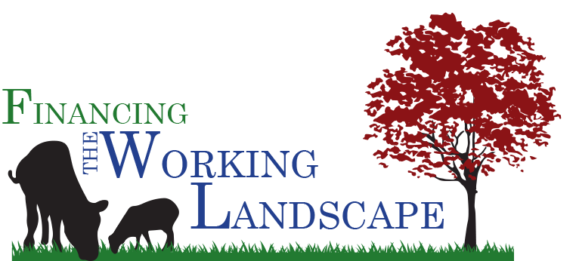
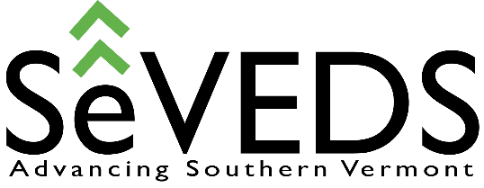

Friday, October 20, 2017 / 9:00 am – 4:00 pm
Weston Playhouse at Walker Farm, Weston, VT

Company / Agency: Website:

Contact Person:

E-mail:

Mailing Address:

City, State, Zip: Telephone:

Thank you! for supporting this Free one-day event at Weston Playhouse at Walker Farm on October 20th. Financing the Working Landscape Conference got its start in Middlebury six years ago. It’s our pleasure to bring the event to Southern Vermont where it will connect the region’s entrepreneurs and small businesses in the Ag, food and forestry sectors to financial resources, technical assistance, and service providers available to them. Your sponsorship support will help to cover event promotion and all conference expenses including a local foods luncheon.

*Please select the appropriate sponsorship level below and mail checks payable to BDCC, 76 Cotton Mill Hill, Brattleboro, VT 05301. You may email a (jpg) image of your logo to slang@brattleborodevelopment.com

_____ $1,000 Major Sponsor – Sponsors will receive prominent logo and name recognition on all marketing materials, conference signs, and in the event Program. Representatives will be invited to facilitate a panel.

_____ $200-$500 Conference Partner – Logos will be reproduced on event signage and in the Program.

Conference Cohosts:
Brattleboro Development Credit Corporation
Windham Regional Commission
Strolling of the Heifers
Bennington County Regional Commission
Bennington County Industrial Corporation

