2019 Southern Vermont Comprehensive Economic Development Strategy

January 2019

Prepared for:
Southern Vermont Economic Development Zone
Bennington County Regional Commission & Brattleboro Development Credit Corporation

About:
The Brattleboro Development Credit Corporation is a private, nonprofit economic development organization that serves as a catalyst for industrial and commercial growth throughout Southeastern Vermont, including Windham County and the towns of Readsboro, Searsburg, and Weston. BDCC serves as the State of Vermont’s certified Regional Development Corporation (RDC) for the greater Windham County area. BDCC is one of 12 RDCs throughout Vermont. For more information visit: https://brattleborodevelopment.com/

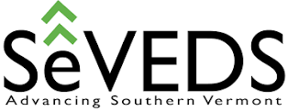
Southeastern Vermont Economic Development Strategies (SeVEDS) is an affiliate of BDCC that grew from a 2008 grassroots effort, initiated by BDCC, to reverse the economic decline of the Windham Region and plan for the economic impacts from the closure of the Vermont Yankee nuclear power plant. In 2014, after multiple years of regional input, education and data gathering, SeVEDS submitted the Windham Region’s federally recognized S.M.A.R.T. Comprehensive Economic Development Strategy for federal approval. For more information visit: www.seveds.com

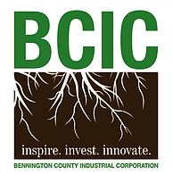
The Bennington County Regional Commission (BCRC) was created by the seventeen towns and villages it serves and works on behalf of those municipalities to build strong, resilient and sustainable communities, to foster economic prosperity, and to promote a high quality of life for residents of the region. For more information visit www.bcrcvt.org.

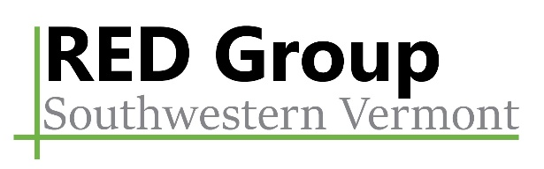
The Regional Economic Development Working Group (RED Group) is a volunteer body committed to increasing the shared prosperity and quality of life for the seventeen municipalities in southwestern Vermont. The group has a diverse membership that reflects the varied community, business, workforce, and demographic characteristics of the region. The RED Group focuses on the internal and external economic development issues that affect the Bennington County region as a whole; the regional implications of local economic development issues; the process of regional economic development from local, state, and federal perspectives; and options for future initiatives.

Table of Contents
Executive Summary i
Background 1
Existing Conditions 1
CEDS Vision, Values, Goals, and Objectives 13
Strategic Projects, Programs, and Activities 17
Attachment Directory: 28

Executive Summary
Beauty, nature, village centers, recreation, arts, culture, and community – these are some of the words that were used by Southern Vermont residents to describe what they love about their region. Southern Vermont, encompassing Bennington County and Windham County, is made up of dozens of towns and villages, 80,000 residents, and countless stories of communities and neighbors working together to solve small and large challenges. Currently, the region is facing what might be its most significant challenge – reversing years of decline in Southern Vermont – mirroring much that has resulted in a shrinking population, fewer job opportunities, and declining public and private investment. Southern Vermont is recovering from other unique challenges which have provided opportunities for the region to demonstrate leadership in rural economic development that has been recognized nationally:
- the 2014 closure and decommissioning of the Vermont Yankee Nuclear Power Plant – the former largest employer in the Windham Region
- elevated levels of PFOA that lies directly downwind of the ChemFab facility in North Bennington requiring major public water infrastructure investments
- questions surrounding the future of the Hermitage Resort, a major employer in the Deerfield Valley and lingering economic impacts from the 2011 T.S. Irene flooding
The Southern Vermont Economic Development Zone was created by the Vermont State Legislature as a vehicle to develop this Comprehensive Economic Development Strategy (CEDS) and work towards a vision of Southern Vermont that is no longer in decline but rather a region working to reverse the trends that many rural communities are facing around the United States. There is no longer the luxury of waiting and hoping that some other organization or entity will solve these problems, the time is now and the Comprehensive Economic Development Strategy for the region is the catalyst for change.
Throughout this document you will see two terms used to describe the region:
Southern Vermont describes the geographic location and includes the geographic regions of the Regional Planning and Development Commissions and includes Bennington County, Windham County and the Town of Weston in Windsor County
SoVermont is the branding that has been created to describe the regional initiatives being jointly pursued in the goal of creating a stronger region, economy, and workforce in Bennington and Windham Counties.
Through a process which included data collection, review of past planning initiatives, discussions with stakeholders, 15 public meetings, and 5 focus groups, several critical issues emerged that highlighted the assets and challenges of Southern Vermont, all of which are addressed as part of the strategy. Using this information, a vision statement, set of values, goals, and objectives were crafted that will address the critical issues facing residents and businesses in Southern Vermont and help address the urgent needs of the community.
This CEDS represents a five-year plan to begin to work together to change the future of Southern Vermont. It outlines projects and needed actions that will require efforts from known and unknown partners across the region. As of this writing, there is no Southern Vermont Zone entity capable of being tasked with comprehensive implementation, and so development of projects and more detailed planning will rely largely on the existing individual county level structures. As capacity and experience continue to develop we expect to see new and emerging collaborations across the zone, making those determinations on a project by project basis.

2019 SoVermont Comprehensive Economic Development Strategy
VISION STATEMENT | In 2030, the Southern Vermont Economic Development Zone will be home to a resilient, creative, and inclusive community in which businesses and people thrive and prosper.

VALUE STATEMENTS | The values driving this Comprehensive Economic Development Strategy are for SoVermont to increase prosperity for all by being welcoming, forward thinking, healthy, and outstanding. | Welcoming: Neighbors, Businesses, Networks, Diversity
 |  | Forward Thinking: Policies, Education, Companies, Services
 |  | Healthy: Families, Environment, Economy, Downtowns, Collaboration
 |  | Outstanding: Culture, Recreation, Location, Resiliency

GOAL STATEMENTS  Statements outlining what is intended to be achieved | - Strengthen Business
 | - Support People

OBJECTIVES  Designed to meet the goals of strengthening business and supporting people | - Increase our Population: Attract more people to live in Southern Vermont, to participate in the community, the workforce, and support the business and civic environment.
 | - Improve our Physical Infrastructure: Make the critical infrastructure improvements so that Southern Vermont is resident and business ready.
 | - Enhance our Social Infrastructure: Improve quality of life and stability for residents.
 | - Expand our Business Infrastructure: Create an environment that will encourage more jobs and opportunities in Southern Vermont.
 | - Develop our Economic Development Capacity: Enhance the ability for economic development professionals and partners to play a role in implementation.

PRIORITY ACTIONS  Actions to pursue immediately to address critical issues and build momentum for future efforts | - Apply to the U.S. Economic Development Administration for SoVermont Economic Development District designation and funding.
 | - Focus resources and investments on helping existing residents, including students, young adults, and families, stay in the area.
 | - Utilize SoVermont marketing materials to highlight the intersection of quality of life and opportunity to attract qualified talent from outside of the region.
 | - Combine real time assessments with existing industry surveys to better understand the workforce needs, both current and projected.
 | - Undertake research to develop initiatives a clear description of the broadband and cell access problem(s),

Background
The Southern Vermont Economic Development Zone (“Zone”) includes Bennington County and Windham County and was first established by the Vermont Legislature in 2015 with recognition of the power of collaboration. There are significant challenges for both counties and opportunities for shared solutions, coordination of efforts, and a need for a more targeted and strategic approach to economic development. One of the outcomes of the creation of the Southern Vermont Economic Development zone was application for funding to the Economic Development Administration (EDA) to create a Comprehensive Economic Development Strategy (CEDS). The EDA defines a CEDS as the “result of a regionally-owned planning process designed to build capacity and guide the economic prosperity and resiliency of an area or region.”
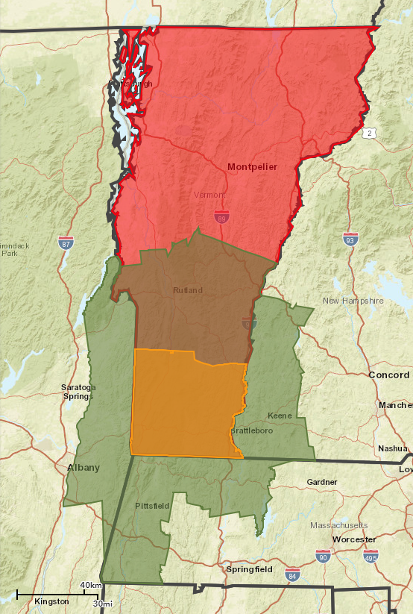
With funding awarded in 2017, the Southern Vermont Economic Development Zone began work on the creation of a CEDS (SoVermont CEDS) with coordination from the Regional Economic Development (RED) Group on the Bennington County side and the Southeastern Economic Development Strategies (SeVEDS) Board on the Windham County side. These two groups worked both independently and jointly to identify goals and objectives for the Zone that recognize the similarities and differences between the two counties and 44 towns.
Figure 1: Map of Vermont, Reference Region and Southern Vermont Zone

Reference Region
Southern
Vermont Zone
Source: Esri
Vermont
The CEDS document summarizes the major findings of the research that led to the development of the vision statement and the Action Plan Matrix with more detail provided in the attachments

Existing Conditions
As a first step to completing the CEDS, a review of data was conducted to understand the socioeconomic conditions in Southern Vermont compared to other study areas, including neighboring counties in New York, Massachusetts, and New Hampshire (“Reference Region”), the entire State of Vermont, and the United States. This analysis is included as Attachment 2: Economic Base Analysis to this report. The main findings are summarized below along with information learned from the public meetings, stakeholder interviews, review of existing material, and focus groups.
- The population of the Zone is getting smaller and older at a rate faster than the comparison geographies. This demographic trend is one that is well-known and reported but it is crucial to consider when creating an economic development strategy as it puts considerable strain on the Zone’s ability to attract and retain companies and other employers. With employees aging out of the workforce, business owners looking to retire, and a shrinking labor pool, companies are experiencing significant challenges when it comes to finding the right employees with necessary skills. Limited workforce availability constraining growth is occurring in nearly all industries with more significant challenges in some of the largest industries in the region, including Health Care and Manufacturing.
The trend of an aging and declining population is not unique to Southern Vermont and many communities throughout New England are struggling with similar challenges. Nevertheless, a successful economic development strategy will need to consider ways to attract and retain a younger population to create an adequate pipeline of workers for employers to remain and expand in the area. In addition, strategies to retain older workers in the workforce for a longer period are also needed.
- The median household income in the Zone is just under $52,000 and is only projected to grow by 7% over the next five years, compared to much higher income levels and faster growth in the other study areas. The median household income in the United States is just above to $59,000 and projected to grow by 11% over the next five years. Lower income levels impact the ability for residents to participate in the local economy, buy and maintain homes, have reliable transportation, access health care, and purchase other goods and services that support sustainable and vibrant economies.
The wages employers can offer their employees is dependent on several factors; however, there are proactive measures that can be included in the economic development strategy that will work to increase the overall median household income. These strategies should focus on: increasing training available for the existing workforce so they can earn higher wages; looking to attract and retain high-quality and high-earning jobs; and establishing support systems for people to have the opportunity to participate in the workforce through transportation, child care, and other initiatives.
- The Health Care industry is the largest industry by current number of jobs and projected to continue to grow. Major employers in the Zone include Southwest Vermont Medical Center, the Brattleboro Retreat, and Brattleboro Memorial Hospital; these employers and the Health Care industry as a whole play a significant role in the regional economy. With a range of employment opportunities at these facilities, from nurses to surgeons and receptionists to managers, health care provides a significant source of employment and potential career pathways for many employees.
Health care is important to the local economy for a number of reasons. Health care is a large source of jobs and having a variety of quality health care options is vital to attract and retain residents. Access to health care is an indicator of quality of life and people looking to relocate often consider the variety, quality, and reputation of a region’s health care options. Supporting the healthcare workforce pipeline is crucial to expanding existing capacity and ensuring continuance of high quality care in the region.
- Tourism is a critical industry cluster for Southern Vermont. This cluster in Southern Vermont is made up of industries including Accommodation and Food Services (5,390 jobs), Retail Trade (5,376 jobs), and Arts, Entertainment, and Recreation (880 jobs). Earnings in this industry cluster are lower than the average, with average earnings ranging from $27,000 to $37,000 compared to the average earnings across all industries at $49,500. This industry cluster also has high levels of seasonality.
The tourism cluster for Southern Vermont is important not only because it drives economic activity from people visiting the area and bringing money in, it also serves to improve the quality of life for those that live here and can be a recruitment tool. Having high quality places, nightlife, cultural amenities, recreation resources, and other assets that are attractive to visitors also make it a great place to live. While the sectors serving visitors are crucial to Southern Vermont employment, it is just as important to support those sub-sectors to create high quality places for residents. Strategies to serve the tourism industry should be developed to continue to look for ways to increase the length of the season, apply innovative approaches to marketing (including converting visitor attraction into new permanent residents), find ways for employees to have year-round work, and help businesses remain flexible to the changing trends of tourism.
- The fifth largest industry in Southern Vermont Zone is Manufacturing, with just over 4,700 jobs in 2017 with equal distribution but different concentrated subsections in each county. With high paying and consistent work, the Manufacturing industry can continue to be a stable source of employment for many workers in the region. Within the Manufacturing industry, the largest subsector is Plastics Product Manufacturing (572 jobs), technology driven precision manufacturing and optics make up an additional 500 jobs and job growth is occurring in value added food production.
Top industries within the manufacturing sector cover a range of sectors from plastics, motor vehicles, paper, dairy, and food products. The Plastics Product Manufacturing subsector is projected to grow 3% from 2017 to 2023 adding 15 jobs. Pulp, Paper, and Paperboard Mills is the most highly concentrated subsector in the Zone with a location quotient of 11.53. Within value added food production sectors, the top industries, by number of jobs, include Commercial Bakeries (164 jobs), Fluid Milk Manufacturing (189 jobs), Cheese Manufacturing (71 jobs), and Frozen Specialty Food Manufacturing (70 jobs).
Overall, the data analyzed in the Economic Base Analysis provides an understanding of the existing conditions in Southern Vermont and beyond. However, this data does not capture the emerging opportunities that are made possible due to the unique energy and vision of the residents around particular niche industries. In a place like Southern Vermont, it is not going to be one or two major employers coming to town that will “fix everything,” but rather a concerted effort by multiple different industry partners with support from the Southern Vermont economic development sector to innovate, be nimble, find solutions, and get creative in order to be sustainable and adaptable.

Cluster Analysis
The rural economy in Southern Vermont is highly diversified with different strengths shown in each county. Because of this, it was challenging to identify specific industries or clusters to focus attention. The CEDS does identify a need to conduct additional targeted industry research to identify emerging opportunities that would warrant focused investment in resources, however, we came to the conclusion that the best use of limited economic development resources would be less on targeted sectors and more on specific economic development initiatives that would provide desired outcomes in many different sectors (higher than average wage, increased training, new jobs providing benefits
Windham County has previously identified targeted sectors in their 2014 Windham County CEDS, including:
- Technology driven precision manufacturing
- Business and technology services
- High quality post-secondary education
- Transportation, distribution and logistics
- Hospitality, retail, arts and tourism
- Healthcare
- Green building products and services
- Niche agricultural products

While originally identified for Windham County in 2014, precision manufacturing and value-added food production are emerging opportunities for both counties that warrant continued research, analysis, and potential strategic investments. However, with significant underlying infrastructure issues impacting all industries, it is increasingly critical to focus on those rather than target investments in specific clusters.

Infrastructure
The following is an overview of the infrastructure that supports economic and community development in Southern Vermont. Additional detail on these assets and challenges can be found in the individual county plans which were reviewed as part of this CEDS process.

Transportation
One of the strengths of Southern Vermont is its ease of access and transportation networks. Southern Vermont enjoys easy access to Albany, Boston, New York, and other parts of New England.
- Route 9 is a state highway that runs between the New York/Vermont border and the Vermont/New Hampshire border. Going between Bennington and Brattleboro, VT 9 ascends and descends the Green Mountains, but can be treacherous during winter months.
- Route 7 is a US Route that runs from southwestern Connecticut to the I-89 interchange just south of the Canadian border. It is the main artery of Bennington County, and provides access to Rutland and Burlington to the north, and the Berkshires to the south
- Interstate 91 is a highway that runs between Connecticut and Canada, through Windham County. I-91 provides easy access south to population centers of New Haven, Hartford, Springfield, and other points south.
- Bus transportation is available through The Current in Southeastern Vermont, the MOOver in the mountain towns along Route 100 and the Green Mountain Express in Southwestern Vermont.
- Amtrak has daily service on the Vermonter line between St. Albans and Washington DC that stops in Bellows Falls and Brattleboro. Additionally, there is the Shires Connector (bus) which links Manchester and Bennington multiple times per day to Amtrak service to Manhattan and beyond.
- Major airports in close proximately to the region include Albany International Airport, Bradley International Airport, and Manchester International Airport.
- Ride sharing services have recently expanded service to Southern Vermont.

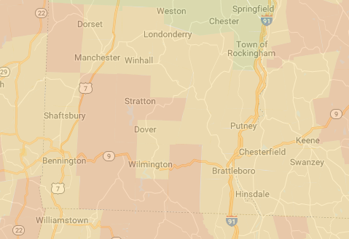
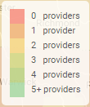
Broadband
Figure 2: Internet Competition Map: Source BroadbandNow.Com
The issue of limited broadband access came up throughout the interviews. Access varies throughout the two counties. According to BroadbandNow:
- The average download speed in Brattleboro is 20.60 Mbps. This is 13.6% slower than the average in Vermont and 97.8% slower than the national average.
- The average download speed in Bennington is 38.08 Mbps. This is 59.8% faster than the average in Vermont but 7.0% slower than the national average.
- The average download speed in Manchester is 18.41 Mbps. This is 24.5% slower than the average in Vermont and 123.5% slower than the national average.
- The average download speed in Bellows Falls is 13.10 Mbps. This is 46.2% slower than the average in Vermont and 214.0% slower than the national average.
Figure 2 shows the internet provider competition for Bennington and Windham Counties based on information from BroadbandNow. The extension of the “last mile” of broadband is an ongoing conversation throughout Vermont and due to the rural nature of parts of Southern Vermont it can be challenging to make it financially feasible to complete the system. While it is financially challenging to complete the “final mile” of infrastructure, it remains that there are residents in Southern Vermont without adequate access to internet. As more of daily interactions are put online, such as access to health records, government events, and education resources, it increases residents’ barriers to these services and makes it more challenging to provide resources in an equitable way. Furthermore, many agricultural and forestry related industries operate in the very rural areas and as they look for ways to diversify to remain viable, they will become more dependent on fast and reliable internet connection.

Water and Wastewater
One of the challenges for economic development in Southern Vermont is differing water and wastewater systems throughout the towns and villages in the region. Some communities have plenty of capacity whereas others have limited remaining capacity, impacting their ability to pursue development and redevelopment projects. Creating an inventory of the capacity and priority projects in each town and village is an action outlined in the CEDS and will help guide resources towards water and wastewater projects that align with the communities’ goals.
Beyond standard water and wastewater for residential and commercial uses, there are issues related to byproducts of various manufacturing and production process, such as value-added food production and paper mills. Finding innovative solutions to these issues will help not only local communities but could be replicated throughout the state and country as many communities are dealing with similar issues.

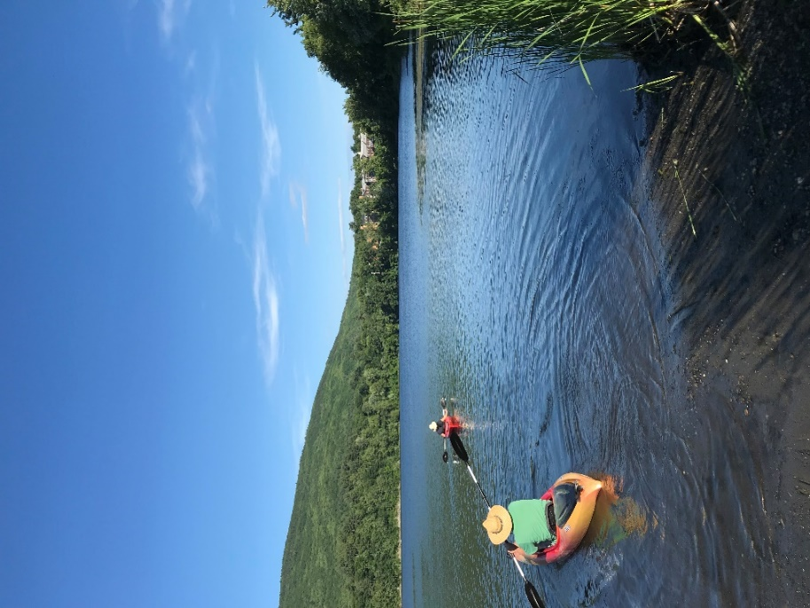
Natural Resources
Figure 3: West River in Brattleboro
Southern Vermont is rich with natural resources that serve to support jobs and high quality of life, act as recreational assets, and provide classic Vermont viewscapes. Forestry and agriculture continue to be sources of economic activity in Southern Vermont. Residents and visitors alike take pride in various natural amenities that Southern Vermont has to offer. The Green Mountain National forest and various state parks offers hiking, camping, biking, and snowmobiling opportunities. Harriman Reservoir, located outside of Wilmington, offers opportunities for boating, as do the Connecticut and West Rivers. Clean water and fresh air are two of the most treasured assets by residents in Southern Vermont and there is a high degree of importance placed on environmental protection and conservation. The Green Mountains, many rivers and lakes, Robert Frost Stone House, Dorset Marble Quarry, Naulakha (Rudyard Kipling house), Hildene (Lincoln family home), the Bennington Monument, the Molly Stark byway are just some of the natural and historic destinations in Southern Vermont.

Resiliency
Southern Vermont understands the need to be resilient and has identified it as a driving value of this Comprehensive Economic Development Strategy. From Tropical Storm Irene, that caused a reported $700 million in damages for Vermont, to the closure of major employers like the Vermont Yankee nuclear power plant, economic development professionals in Southern Vermont have been working to create a more resilient and diverse economy that can withstand the test of time. Southern Vermont residents have been and will continue to be resilient and find ways to cope with the changing times through preparation, hard work, and collaboration.

Natural Disasters
Southern Vermont is especially prone to disasters related to flooding and has begun to feel the impacts of climate change. With reliance on the outdoor recreation industry, the desire to address issues related to climate change and remain resilient is especially important in the face of changing weather conditions. One way that the outdoor recreation industry has worked to become more resilient is to generate supplemental income by increasing the length of the on-season, creating additional attractions and events throughout the year, and continuing to make investments in facilities. Beyond private industry, local municipalities have found themselves needing to make substantial investments in infrastructure to address issues related to flooding such as replacing roads and bridges. As a region, Southern Vermont continues to regard the natural environment as a public benefit, a buffer against climate change, and a beneficial resource.
Figure 4: Mount Snow Oktoberfest brings people to Southern Vermont in the off-season. Photo source: www.mountsnow.com

Economic Resiliency
Economic development professionals have seen the impact that reliance on a certain industry or employer can have on a community when something goes wrong. The closure of Vermont Yankee and the loss of 600 high-paying jobs in Windham County continues to have a profound effect on the local economy. In response to this, the SoVermont CEDS focuses on creating a diversified economy that does not rely on an individual company or industry sector.
While ensuring that the economy is diverse is an important step, preparing to handle major closures or downsizing is also important. Southern Vermont recognizes this as a potential challenge and continues to prepare to mitigate potential challenges. Creating up-to-date resources related to occupation needs, understanding the skill sets needed by various employers, working to support businesses with financing, and keeping in close connection with employers to be prepared to address issues early are all aspects of the Southern Vermont resiliency plans. Business retention and expansion efforts and regular contact with the business community helps Southern Vermont remain strong.

Collaboration, Capacity, and Inclusion
Through partnerships like the Southern Vermont Economy Project, the creation of the SoVermont Marketing and Recruitment campaign, the Southern Vermont Economy Summit, and several other examples, professionals in Southern Vermont continue to pursue collaborative regional economic development. By increasing the amount of resources available, including both financial and personnel, the region is able to address complex challenges that impact the community.
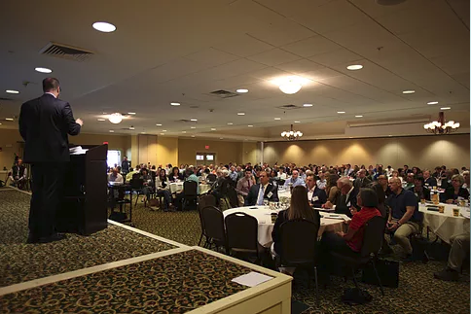
Beyond collaboration and building capacity within existing organizations, in order to truly be resilient, Southern Vermont needs to increase the diversity of the residents and businesses. In a changing world, communities that are not open, welcoming, and flexible will no longer be sustainable. There has been recent recognition of the need to focus on increasing inclusivity in Southern Vermont and there have been success stories, but there is still work to do in order to be a welcoming community to all people. Discussions around the intersection of economy, inclusion, and racism have identified substantial shortfalls in the region when it comes to creating a community that works for all. Continuing to have these difficult conversations will offer a chance for those most impacted to be heard and work towards solutions that will benefit current and future generations and lead to greater sustainability and resiliency for Southern Vermont.
Figure 5: 2018 Southern Vermont Economy Summit

CEDS Recommendations Related to Resiliency
The topic of resiliency is addressed in a number of different ways in this CEDS document, including specific recommendations related to both communities and businesses as well as for the businesses. Some of the specific recommendations include:
- Review of sector-specific issues related to climate change such as winter recreation assets and natural resource based sectors and how to support businesses in efforts to adapt business plans to meet changing conditions.
- Business training initiatives to help with disaster preparation, including staff contacts, inventory, insurance claims, and other support services that will help workers and businesses fully recover following any event.
- Recommendations related to address climate change through energy innovations that will increase resilience, alternative transportation options and charging stations, and support for the green economy.
- Support for continued regional collaboration to deal with the most challenging economic and demographic issues undermining resiliency Southern Vermont.
- An objective to address demographic threats and to increase the diversity of Southern Vermont through a targeted immigration program, services for existing residents, and increased support for minority and women owned enterprises.
- Equitably connecting communities to the global economy, healthcare, education and government services by expanding cell/broadband coverage

Regional and State Initiatives and Alignment
It is critical that the SoVermont CEDS is aligned with the other economic development work being done in the State and region. The following is a summary of how the specifics of the SoVermont CEDS align with and build on the various initiatives underway.

State Alignment
The State of Vermont has a Comprehensive Economic Development Strategy that was developed in 2014 (Vermont 2020-CEDS) and outlines a mission to: Improve the economic well-being and quality of life of Vermonters while maintaining our natural resources and community values.
The SoVermont CEDS supports that mission and the vision and goals align with the statewide initiatives. Specifically, this CEDS looks to improve prosperity for all Southern Vermont residents and businesses through targeted business support, workforce attraction and retention efforts, and physical infrastructure improvements. The goals of maintaining natural resources and community values is also found throughout the SoVermont CEDS in objectives related to water and wastewater capacity and civic and community engagement.
More specifically, the SoVermont CEDS aligns with the work of different agencies in the State of Vermont and intends to leverage the existing economic and workforce development initiatives, including but not limited to the following:
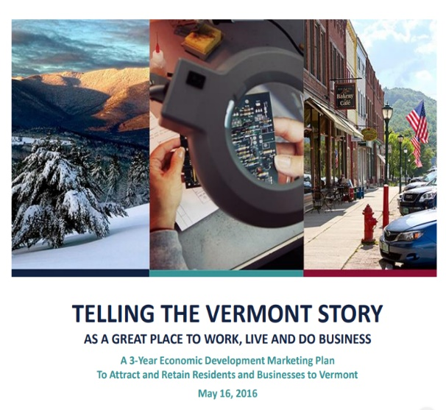
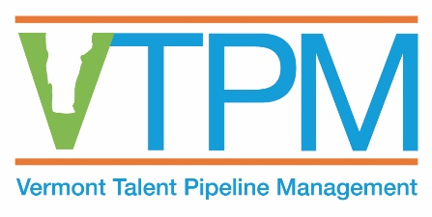
- Vermont Talent Pipeline Management (VTPM): This initiative aims to decrease the supply gap that exists between the type of skills employers are looking for and the types of skills that workers possess. While the VTPM is being conducted at a larger state and regional level, the SoVermont CEDS will build on this through objectives directing more targeted assessments within Southern Vermont to identify occupations and skills that are needed by local employers and developing partnerships, programs and initiatives to bridge those gaps.
- ThinkVermont Innovation Grant: This program was established to make it possible to respond to the financial needs of entrepreneurs quickly and without the typical restrictions placed on traditional public funding tools. The SoVermont CEDS also identified the need to increase access to capital for business owners, including entrepreneurs, and includes strategies related to expanding funding for innovative projects.
- Economic Development Marketing Plan: Completed in May 2016, the 3-Year Economic Development Marketing Plan was completed with the goal of attracting and retaining residents and businesses to Vermont. The State has received significant media attention related to a number of initiatives, like the $10,000 for remote workers to move to Vermont and the Stay-to-Stay initiative throughout the state. The SoVermont CEDS intends to build on the tactics identified in the marketing plan to attract and retain people in Southern Vermont.
- Vermont Department of Labor: This agency can help list jobs, collect data, and provide recruitment and training services. The SoVermont CEDS outlines strategies related to increasing the available job listing resources and supporting employers in their efforts to recruit qualified applicants. The department of labor also funds key state and regional workforce initiatives that make it possible to respond to talent demand by working with different local constituencies.
- Community College of Vermont (CCV): With academic centers in both Bennington and Brattleboro, CCV is a longstanding partner for workforce and economic development in the region. The 2019 SoVermont CEDS identifies numerous opportunities to continue to collaborate and support CCV’s efforts to recruit, retain, and train the needed workforce.

Regional Alignment
Both Bennington and Windham Counties are actively engaged in a number of initiatives that will align and build upon the work of this CEDS. This includes recent efforts with regional partners in adjoining counties in New Hampshire, Massachusetts and New York. This CEDS has been designed to support the continuation of work being done, highlight opportunities where programs can be shared and expanded through regional collaboration, and develop new ideas that should be pursued by one or both counties.
This CEDS builds on the recent regional planning work completed by communities in Southern Vermont, including:
- 2014 Windham County CEDS
- Windham County Regional Plan
- Bennington Regional Plan
- Northshire Economic Development Strategy
- The Southern Vermont Economic Development Zone Report
- Town of Bennington Housing Study
- Bennington Downtown Area Wide Plan
- BCRC Regional Energy Plan
- Town of Bennington Housing Report
- Post-Irene Southern Vermont Recovery Project
The two driving organizations of the CEDS process include the Brattleboro Development Credit Corporation (BDCC) and the Bennington County Regional Commission (BCRC)/Bennington County Industrial Corporation (BCIC). These organizations operate with differing levels of resources. However, they each is making strides implementing both separate and collaborative economic development initiatives. Some of the critical initiatives that the organizations have been working on, which also align with the CEDS include:
- Startup and entrepreneurial support: The Southern Vermont Business Accelerator and Southern Vermont Economy Project are initiatives aimed at expanding resources, capacity, and opportunities for startup businesses in the region. These programs are geared towards building on existing assets as well as attracting new investment to the area. New business seminars and business support services are currently being provided in the region and connected to partners at the Lightning Jar and Startup 802 in Bennington and the Hannah Grimes Center in New Hampshire. The SoVermont CEDS identifies specific objectives related to supporting the entrepreneurial ecosystem, including expanding access to capital, focusing on increasing training programs, and encouraging youth entrepreneurship.
- Existing business services: BCRC and BDCC both currently have business visitation programs to help support existing businesses in their efforts to remain viable and expand. The SoVermont CEDS recognizes the need to continue to expand this type of programming to support expansion projects through technical and financial assistance. Specific strategies include formalizing a business visitation program, responding to identified problems and needs, identifying and developing targeted training opportunities, and enhancing awareness related to available business support services. A 2014 state settlement with Vermont Yankee included 10 Million Dollars in economic development funds for the Windham County Economic Development Program. This settlement was heralded as a benchmark for communities facing the economic losses of a nuclear power plant shutdown. The funds have been used to successfully support the expansion and retention of hundreds of jobs in the Windham Region and have been almost completely committed. While these funds have been a tremendous short-term boost, communities facing this type of shutdown and massive economic disruption need access to a decade’s worth of supports and BRAC like prioritization for federal programming.
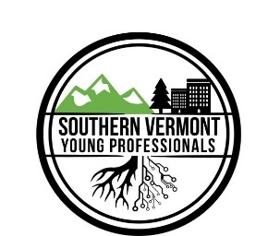
- Young professional recruitment and retention: Bennington County and Windham County both have growing young professional networks that host various events to bring together young people to learn, network, and connect. Additionally, work is being completed related to targeted expertise recruitment and retention program to make sure the critical employers have the workforce they need. The SoVermont CEDS intends to build on these successes by expanding the funding for the program, expanding the networking opportunities, and relying on these groups to partner with in the effort to attract and retain young people.
- Workforce development: Recognizing that increasing the size and quality of the workforce is the number one issue for businesses in Southern Vermont, the region has been working to develop a number of programs to help connect residents with opportunities as well as train residents to be able to better participate in the economy. The Southern Vermont Workforce Center of Excellence was created as a result of the 2014 Windham CEDS and plays a crucial role in aligning the workforce with industry needs in Windham County. BCIC’s Workforce and Education Committee is leading the region’s workforce efforts with a variety of programs that develop and retain talent at all age levels including internship and certification programs, career awareness and readiness programs, and early education programming as well. The 2019 SoVermont CEDS identifies ways to continue to pursue this goal, including additional apprenticeship in both counties, internship programs in Bennington, establishing a real-time assessment of the occupations/skills needed by employers in Windham, and a two county collaborative SoVermont effort to attract and retain workforce in the area.
- Regional coordination: In rural areas the need to collaborate with neighboring communities and counties is critical. In an area as independently minded as Southern Vermont this can sometimes be a challenge. However, organizations and municipalities are starting to see that the only way to move toward their goals is to work together. There has been increased collaboration as a result of the 2014 Windham CEDS within Windham County and over the last five years there has been increased collaboration between the leadership in the two counties but there remains room for improvement. Identifying areas where there will be greater effectiveness, improved quality and delivery of service or a cost savings as a result of shared services and shared expertise is an important role of the implementation for the 2019 SoVermont CEDS.
Opportunities and Challenges Assessment
The findings of the interviews, data analysis, capacity assessment, and knowledge of the region were compiled into a list of the Southern Vermont opportunities and challenges related to economic development and quality of life. This assessment is used to inform the vision, goals, objectives, and actions identified in the Action Plan Matrix. The list of opportunities and challenges are outlined below and further discussed throughout this document.
The opportunities that exist in Southern Vermont are vast, ranging from natural resources, recreation, educational and cultural institutions, momentum from recent planning initiatives, growing collaboration to address workforce issues, creative and innovative residents and businesses, and an understanding that economic development is inclusive of community development. Building off the assets that exist, supporting the businesses and residents that live in the region, and protecting the natural environment were important themes throughout the public engagement process.
The challenges Southern Vermont is facing are similar to other New England regions, including declining and aging population, need for upgraded infrastructure, challenges related to rural transportation and communication options, workforce-industry mismatch, lack of diversity, and the continued impact of climate change. These are all issues that were also identified in the 2014 Windham CEDS as well as in other planning initiatives that have been completed for the area. Without continued acknowledgement that these issues demand urgent attention, Southern Vermont will see further declines in school-aged children, diminishing tax revenues, increased need for public services, and disproportionate service costs. Though they are not new or unique, the challenges need to continue to be identified and work needs to continue to make positive changes.

- Aging and declining population
- Limited workforce (size and skills)
- Limited entrepreneurial and customer base
- Inconsistent cell and broadband connections
- Deteriorating and limited infrastructure
- Lack of capital for investment
- Lack of capacity for economic development
- Tension among residents between wanting to change and not wanting to change
- Lack of awareness of economic development organizations and programming
- Drug, substance abuse and mental health issues
- Limited housing choice and affordability in communities that people with a choice want to live in.
- Inadequate child care options
- Lack of shovel-ready development sites to support housing and economic development
- Climate change – economic dependence on snow, storm-related impacts particularly on village centers
- Rural development issues – isolation, transportation, social services, connectivity
- Lack of diversity in the population
- Differences between the eastern and western parts of the region – particularly I-91 corridor
- Limited scale of 4-year higher education institutions
- Distance from economic / political center of Vermont
- Concern that economic growth is unlikely or undesirable

- Natural resources – recreation, clean air and water, value-added agriculture opportunities
- Quality of life
- Authentic and traditional downtowns
- Access to tri-state areas (NY, MA, NH)
- Small and accessible – access to policy makers, nimble, flexible, connected
- Strong “Vermonter” identity and individual community identity
- Potential in regional approach – recognition that teamwork is necessary
- Regional and International recognition for Windham CEDS implementation and other planning efforts
- Growth in certain manufacturing sectors including plastics product manufacturing and dairy product manufacturing
- Tourism, art, and cultural amenities
- Redevelopment opportunity for complex projects
- Consumer trends towards local, farm-to-table, hand crafted products
- Entrepreneurial/do it yourself/independent attitude
- Specialty educational resources such as Landmark College, Greenwood School, ski schools, New England Center for Circus Arts, SIT, and others
- Shared concern for maintaining the quality of communities, environment, and Vermont way of life

SoVermont Opportunities
SoVermont Challenges

SoVermont CEDS Vision, Values, Goals, and Objectives

VISION STATEMENT | In 2030, the Southern Vermont Economic Development Zone will be home to a resilient, creative, and inclusive community in which businesses and people thrive and prosper.

VALUE STATEMENTS | The values driving this Comprehensive Economic Development Strategy are for SoVermont to increase prosperity for all by being welcoming, forward thinking, healthy, and outstanding. | Welcoming: Neighbors, Businesses, Networks, Diversity
 |  | Forward Thinking: Policies, Education, Companies, Services
 |  | Healthy: Families, Environment, Economy, Downtowns, Collaboration
 |  | Outstanding: Culture, Recreation, Location, Resiliency

GOAL STATEMENTS  Statements outlining what is intended to be achieved | - Strengthen Business
 | - Support People

Objectives and Strategies
The objectives and strategies identified below are designed to work toward achieving the goals of strengthening business and supporting people:
- Increase our Population: Attract more people to live in Southern Vermont to participate in the community, the workforce, and support the business and civic environment.
The shrinking and aging population in Southern Vermont is having a considerable impact on the economy. An issue that is impacting much of rural America, Southern Vermont is not alone in trying to reverse this trend, and must leverage its ability to act regionally and step forward with competitive regional solutions nevertheless it is a critical issue that needs attention. Employers need an adequate talent pool. The region needs entrepreneurs. Businesses need customers. In addition to the impact on the economy, the declining population is limiting the number of people able to support local businesses and participate in civic and philanthropic organizations.
The strategies within this objective include:
- Retain and attract young people (between the ages of 24-45)
- Retrieve, retain, and attract workforce
- Retain and attract diverse population

- Expand our Business Infrastructure: Create an environment that will encourage more jobs and opportunities in Southern Vermont.
Supporting existing businesses in all sectors from value added agriculture to healthcare and IT within Southern Vermont is critical for attracting residents and workers, increasing prosperity for all, and supporting a healthy economy. Continuing to help businesses remain financially viable, resilient in the face of disaster, pursue expansion, continue to innovate, and find the workforce they need, are all initiative currently being pursued by economic development professionals in Southern Vermont. Increasing workforce development helps better match people’s skills to the needs of employers. Encouraging diversity in the workforce and businesses in Southern Vermont increases economic diversity and resiliency. Encouraging entrepreneurship helps support continued growth of the economy which plays a major role in reaching population goals.
The strategies within this objective include:
- Establish a collaborative regional system to increase training, education, and readiness of the workforce
- Strengthen the Southern Vermont entrepreneurial and innovation ecosystem
- Increase support services and resources for all businesses and sectors
- Enhance business retention, expansion, and attraction efforts
- Define emerging clusters in high wage, high growth job sectors

- Improve our Physical Infrastructure: Make the critical infrastructure improvements so that Southern Vermont is resident and business ready.
In order for Southern Vermont to retain and attract business and people there are necessary infrastructure improvements to be completed. Addressing areas of limited access to broadband and cell service, improving water, waste and wastewater capacity, and enhancing transportation systems will make the area more viable and attractive to current and prospective businesses and residents. Housing also came up as a consistent area of concern related to the ability to attract and retain people of all incomes and ages in Southern Vermont. Finally, strengthening downtowns and village centers is critical to maintaining the Vermont appeal and creating strong communities that people are attracted to and where people can thrive. Any review of existing infrastructure must also address resilience in the face of climate change and increasing natural disasters.
The strategies within this objective include:
- Expand broadband/cell infrastructure
- Support vital downtown and village centers
- Increase number and variety of housing options for all incomes and ages throughout the region
- Address water and wastewater issues
- Enhance transportation infrastructure

- Enhance our Social Infrastructure: Improve quality of life and stability for residents.
Cultural and recreational assets of Southern Vermont are drivers of the economy through the creative economy, the outdoor recreation industry, and the tourism industry. These assets also make Southern Vermont a special and unique place to live. While child care, recreation, and civic engagement may not necessarily be considered traditional economic development issues, they are all tied closely to the opportunities for the residents and the businesses and quality of life. Without access to affordable, convenient, and flexible child care it is especially difficult for families to participate in the workforce in a meaningful and financially feasible way. Finally, increasing civic engagement in all levels of government and sectors will increase participation in local government and decision-making, strengthen community ties, and encourage innovation, creativity and collaboration on some of the most challenging issues for the region.
The strategies within this objective include:
- Expand accessible child, elderly, and other care options
- Expand and support recreation and cultural opportunities
- Increase civic and community engagement

- Develop our Economic Development Capacity: Enhance the ability for economic development professionals and partners to play a role in implementation.
In rural communities throughout America, economic and community development is made possible through collaborations and partnerships, and by creatively leveraging scarce resources. And not unlike other rural areas, implementation of the SoVermont CEDS will rely on partnerships from all sectors of the economy, volunteers, and public-sector organizations, so it is critical that we increase the overall understanding of and capacity for economic development. Being able to showcase and describe the successes, attract the necessary funding, pursue innovation in the field of rural economic development, and work together toward shared goals will be the only to achieve the vision outlined in this CEDS. This requires consistent funding and staffing, the ability to develop expertise and disseminate data and knowledge, and a commitment to build and sustain the partnerships and initiatives necessary to achieve the CEDS economic development goals and objectives through local, sub-regional, and regional implementation.
The strategies within this objective include:
- Enhance CEDS implementation ability
- Develop a communications plan to increase awareness and support of economic development initiatives
- Continue to act regionally

Priority First Steps
While all the strategies are important and should be pursued, the following should be implemented as soon as possible as they will have the greatest impact and result in momentum for the overall effort.
1) Apply to the U.S. Economic Development Administration for SoVermont Economic Development District designation and funding.
2) Focus resources and investments on helping existing residents, including students, young adults, and families, stay in the area.
3) Utilize SoVermont marketing materials to highlight the intersection of quality of life and opportunity to attract qualified talent from outside of the region.
4) Combine real time assessments with existing industry surveys to better understand the workforce needs, both current and projected.
5) Undertake research to develop initiatives a clear description of the broadband and cell access problem(s),

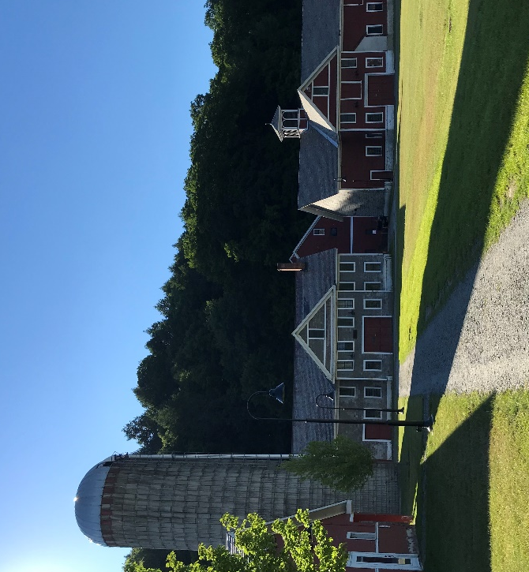

Implementation Approach
BCRC and BDCC and the CEDS Committee will be the primary driver of implementation of this strategy, however, a strategy of this size takes a holistic approach and requires the participation of many different partners, even those that are yet to be created and/or identified in this strategy. The CEDS identifies a number of critical stakeholders that will need to engage in the process in order to make progress towards the joint goals. Some of those partners include:
- Windham Regional Planning Commission
- Bennington County Industrial Corporation
- School Districts and Career Centers
- Chambers of Commerce
- Local and sector-focused Economic Development Organizations
- Private Industry and Employers
- Workforce Development partners
- Real Estate Brokers and Developers
- Regional Financial Institutions
- Towns and Villages
- Housing Trusts and Agencies
- VTrans and subregional transportation providers
- Community College of Vermont, Vermont Technical College and the other regional colleges
- Young professional groups
- State and Federal agencies, public and private funders
What is specifically called out in this CEDS (Objective 5) is the desire to support the continued capacity building of these organizations to improve the implementation of the strategy. Increasing the expertise, skill, staff, and financial resources of the supporting organizations (beyond BCRC and BDCC) will be critical to the desire to move the economy and community in the same direction.
The full Action Plan Matrix, included as Attachment 1, provides additional details regarding implementation including priority level, timeframe, needed resources, and performance metrics.

Figure 6: Downtown Brattleboro
Figure 7: The Retreat Farm

Strategic Projects, Programs, and Activities

Increase our Population

Objective 1

Strategy #1.A. – Retain and attract young people (between ages 24-45)
Encore Workforce and Retirees
Encore workforce is a term used to describe people who may have been in the workforce already and for whatever reason would like to return. Southern Vermont already enjoys a good amount of in-migration from older people who move to the area after a successful career. These residents are celebrated for all that they bring to the community including their wisdom, support for arts and culture, and community participation. This economic development strategy does not intend to make it seem like those contributions are not important to the Southern Vermont economy, but rather it attempts to focus limited resources on areas in the greatest need which is around building the workforce.

I) Focus resources and investments on helping existing residents, including students, young adults, and families, stay in the area. Establish creative tax policy to incentivize investment in existing and development of new high-quality housing stock, develop first time homebuyer assistance, create student loan repayment programs, and research other strategies designed to retain population.
II) Create a "welcome wagon" that is geared towards young people to help them connect with their community and find what they need in order to feel comfortable and welcomed.
III) Identify and support local and regional policies that are attractive to young people and young families including investment in schools, arts and culture, activism and global issue awareness, family friendly workplace policies, and recreation amenities.
IV) Fund and support the Young Professionals groups' efforts to engage young people and continue to offer high-quality programming. Regularly survey members and non-members on what they would like to see the groups do. Provide support for the YP groups bringing the YP Summit to the region, the development of a scholarship program for training opportunities, and the development of a diverse and active membership. Continue to develop membership benefits.
V) Following the completion of the workforce needs inventory (Task 2.A.I), pursue initiatives that directly target young professionals that are in demand by local industry. Research how to identify this population and continue to support projects and programs that encourage them to come and stay in the area.

Strategy #1.B. - Retrieve, retain, and attract workforce

I) Create career pathways informational material focused on those who have already been in the workforce and may be looking for new opportunities (both those currently employed and those who have left the workforce but may want to return). Highlight necessary training and where the training is available. Identify and create additional training programs as necessary.
II) Following the completion of the workforce needs inventory (Task 2.A.I), pursue initiatives that directly target professionals that are in demand by local industry. Work with local employers to better market to and attract qualified applicants.
III) Utilize SoVermont marketing materials to highlight the intersection of quality of life and opportunity to attract qualified talent from outside of the region. Continue to pursue avenues that will bring those who have previously lived in Southern Vermont back to the area.
Figure 8: Bennington Banner article about existing programs in Bennington County
IV) Continue to support and run programs like Dress for Success, interview preparation, resume review, and career fairs.
V) Connect with local Career Centers about how to engage and serve non-typical career center users like New Americans, non-citizens, and accompanying partners who may be looking for work or new opportunities.

Strategy #1.C. - Retain and attract a diverse population

I) Implement a targeted immigration program. Research successful immigration models and best practices (foreign and domestic). Prepare a white paper summarizing the results of the research and recommendations for improvements. Build out the community support for such an approach including public education, cultural competency programming, and community discussions around why it is critically important. Design and execute a targeted immigration recruitment plan.
II) Establish career awareness and exploration programs in K-12 highlighting the accomplishments and successes of people of color. Incorporate presentations, dedicated curriculum, "job shadow", and visual tributes (photos, portraits, etc. on the walls). Incorporate ethnic and social equity training into school curriculum.
Back Home Initiatives: The Case in South Dakota
Back home initiatives, like Dakota Roots, work like marketing programs to draw people to their state or region. Dakota Roots has advisors who will work with a potential transplant to assess job opportunities based on skill and interest. Personal stories offer website browsers to identify with a story and reason to move. The key is to provide personal and specific support that aligns with professional opportunity, with a robust website that tells personal stories and allows potential transplants to search jobs.
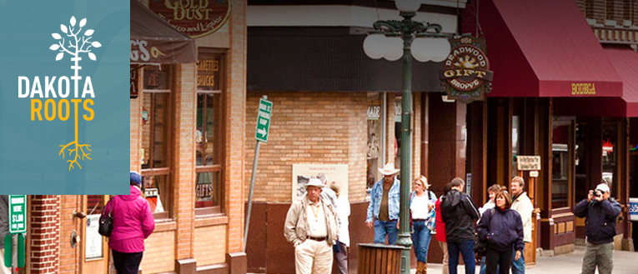
Find more at https://www.dakotaroots.com/
III) Continue to support and participate in round table discussions on issues impacting people of color in Southern Vermont, including the economic implications of racism, discrimination, and lack of diversity.

IV) Review marketing and other communication material for opportunities to include other languages, platforms, and methods of communication to be more inclusive and welcoming.

VI) Identify support networks available to serve New Americans and non-citizens. Consolidate contact information for organizations, individuals, and entities that will assist in distribution of this information. Ensure linkage to community for new immigrants. Work to ensure material is available in a variety of languages and platforms.
VI) Encourage the incorporation of accessible and interactive spaces in development projects to create opportunities for diverse interactions and strengthening community social fabric.

Expand our Business Infrastructure

Objective 2

Strategy #2.A. - Establish a collaborative regional system to increase training, education, and readiness of the workforce

I) Conduct ongoing real time demand assessments in order to inform ongoing adaptive development of programs. Combine real time assessments with existing industry surveys to better understand the workforce needs, both current and projected, from the perspectives of employers and workers. Use this information to improve the workforce system, inform curriculum and program development, and to advocate for additional funds needed for training.

II) Continue to provide regional middle school and high school guidance counselors with written information related to the job opportunities in the area, non-college related pathways, and the latest thinking around the host of avenues available to students after high school. Host career fairs and other events for teenagers related to career opportunities, interview and resume writing skill development, budgeting, available resources, and other life skills to support financial literacy and work readiness.

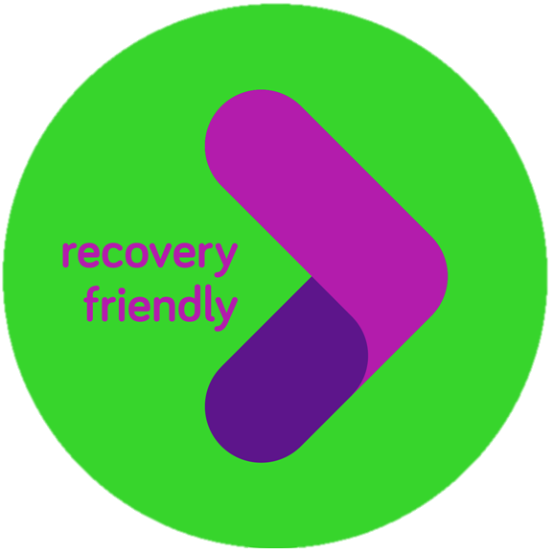
III) Develop a comprehensive workforce system that enhances collaboration between the two counties' workforce networks including expanding existing internship and apprenticeship programs, identification of training opportunities, shared services and resources, and collective marketing and promotion efforts. Ensure regular communication between all partners and ease of understanding by job seekers.
The Recovery Friendly Workplace Initiative
Designed to help employers create a supportive work environment for employees recovering from substance use disorder, this program is sponsored by the Governor of New Hampshire and offers training and resources to participating employers. Recovery Friendly Advisors are assigned to support employers, at no cost, to develop and sustain best-practices that foster a safe environment, provide health education, and promote recovery and prevention in their communities. Ultimately, these changes work to retain employees that are productive, motivated, and safe.
Find more at https://www.recoveryfriendlyworkplace.com/.
IV) Create career awareness and exploration programs for youth and expand work-based learning opportunities and education pathways that interact with, and prepare students for, regional opportunities. Connect students to viable and growing pipelines.
V) Research what other communities are doing to support those in recovery and what services would help them enter the workforce successfully. Implement programs and policies as appropriate. Approach to include employer encouragement, training, and support at all levels to hire and retain employees in recovery. Address stigma and discrimination with co-workers and look to evidence based approaches.
VI) Expand paid internship opportunities for currently enrolled college students and recent graduates in Southern Vermont. Creation and further development of the SoVermont Internship Program in Bennington and Windham County in order to attract and retain young workforce to the region.
VII) Pursue funding for occupations with critical supply-gap concerns, including school psychologists, health care professionals, and construction related trades.

Strategy #2.B. - Strengthen the Southern Vermont entrepreneurial and innovation ecosystem

I) Identify sources of funding for early-stage seed money and promote availability to entrepreneurs and small business owners.

II) Formalize and promote available business acceleration and transition services to potential participants. Expand and adjust services as business community needs change. Increase visibility of the support available, including conducting business visitation meetings at small businesses in all sectors.

III) Support capacity building for innovation leaders, including programming/training, networking opportunities, business plan competitions, and prizes. Continue to bring in experts on various topics such as digital marketing, customer attraction, human resources, and other programs that will support businesses. Use existing entrepreneurial assets (people) to create mentoring opportunities to support younger entrepreneurs.
IV) Regularly highlight and promote local entrepreneurs and the work being done through press releases, newsletters, and other outlets to encourage others to consider entrepreneurship.
V) Support youth entrepreneurship through school and extracurricular opportunities.
VI) Research the feasibility of establishing a Center for Rural Entrepreneurship.
VII) Create events that build and cultivate knowledge networks that promote cross-industry engagement and collaboration.
VIII) Facilitate collaboration between partners including health care, universities, and industry to identify unique Southern Vermont knowledge assets that could be leveraged to address major challenges facing Southern Vermont (substance use disorder, water quality, tick borne disease, obesity, different teaching/learning approaches) and pursue a strategy to become the center for research, training, practical experience, and collaboration in that topic.

Strategy #2.C. – Increase support services and resources for all businesses and sectors
I) Build financial capacity to promote and provide small business development services through regional development corporations. Research the feasibility of creating a regional redevelopment authority to provide guidance to businesses or developers around project permitting requirements. Establish "So you want to open a business" informational material as well as a quick guidance document related to permitting requirements, realistic expectations, contact information for experts, and basic assistance navigating the process.
II) Create a Succession Planning Symposium or set of classes to help retiring business owners sell their businesses and keep them operating in the region. Invite potential second-generation owners to participate and learn useful business practices. Maintain a list of both business owners looking to sell and potential buyers who participate in the program to create matches for business mentoring and/or business sale.

Small Business Training Needs
- Business planning
- Management and supervision
- Online sales and social media
- Human resources
- Revenue forecasting
- Becoming a certified B-corp
- Business resiliency planning
- Business scaling
- Accessing financing

III) Establish funding streams targeted for women, veteran, handicapped, and minority owned businesses locating establishments in downtowns, village centers, and commercial corridors. Establish guidelines for the funds that meet the goals of increasing diversity, supporting small businesses, and helping expand the business offerings.
IV) Conduct an audit of current processes and initiate training related to diversity and inclusion in all aspects of economic development in the area including programming, materials, and communications.
V) Create and operate a more robust “Available Jobs Now” listing program that is hosted on a single regional website. Use this single point to also highlight assets of the region, provide guidance related to relocation, and other supportive information.
VI) Create, maintain, and operate a centralized Business Assistance Center providing information on all assistance programs including available lenders, grant programs, business support services, training opportunities, and other critical information. Expand business assistance as needs change.

Strategy #2.D. - Enhance business retention, expansion, and attraction efforts

I) Formalize a regional business retention and expansion program and business visitation program. Set expectations on the number of businesses to visit each year, ranging from small to large to ensure regular communication with all critical sectors of the economy.

II) Engage with large employers to address areas of opportunity, supply chain possibilities, and shared topics of concern (for example, industry leaders in healthcare and higher education).
Business Visitation
Set priorities related to types of companies to visit, goals related to number of total annual visits, and establish standard practices when it comes to information to be collected and follow-up. Consider subscribing to and using a system such as Executive Pulse or Synchronist as a standardized tool for collecting and monitoring business characteristics and needs.

III) Convene a task force to discuss the challenges related to small businesses in Southern Vermont, including all sectors such as retailers, trades and construction, professional and technical, hospitality and services, and others.
IV) Continue to develop and maintain quality development and financing services for business attraction, expansion and business retention efforts. Continue to work regionally to maintain an inventory of available space for new or expanding businesses. Incorporate key information about available properties, site infrastructure, assets, and other critical data into online/searchable database.
V) Build out the Community Development Financing Institution at BDCC and use it to fund critical projects.
VI) Continue to monitor the Opportunity Zone tax policy program and identify ways to leverage the program. Create informational material for potential investors and train staff on the topic.

Strategy #2.E. - Define emerging clusters in high wage, high growth job sectors
I) Conduct a targeted industry analysis for Southern Vermont to identify emerging opportunities. Consider factors such as higher than average wage, projected job growth, and unique assets in Southern Vermont to guide selection of targets.
II) Review and report average wage data in Southern Vermont and the state, as well as neighboring counties on an annual basis to refine targets and track progress.
III) Inventory business assets in all clusters including supply chain business, facilities, funding resources, and physical facilities. Create a detailed network map to show the regional strengths of Southern Vermont and work to identify emerging clusters and opportunities.
IV) Balance a targeted approach with maintaining a nimble workforce system that has the ability to respond to new opportunities as they arise.

Improve our Physical Infrastructure

Objective 3

Strategy #3.A. - Expand broadband and cell infrastructure

I) Undertake research to develop initiatives a clear description of the broadband and cell access problem(s), extent of the problem by location, and other variables necessary to understand the problem and develop cost-effective responses.
II) For each area with insufficient broadband or cellular service, collaborate with carriers to develop a solution. Focus initially on high density commerce areas and major roadways.

Strategy #3.B. – Support vital downtown and village centers
I) Conduct an analysis of livability by municipality to identify strengths as well as areas for improvement within the region. Start by establishing a list of characteristics for communities where people are moving in and then do a regional assessment of municipalities to provide productive feedback on infrastructure, cultural, and civic improvements/changes.
II) Fund grants to neighborhood associations or committees to be used for community building events, street clean up, community watch programs, and other tools to build great neighborhoods. Convene leaders of the neighborhood groups once a year as part of the Southern Vermont Economic Summit to receive feedback, share successes, and engage them in the conversation about creating great places.

III) Continue to bring small and large events into the towns and village centers and do joint advertising and promotion. Create and widely disseminate a region-wide calendar of events that is up to date and helps avoid double scheduling.
IV) Identify catalyst properties/parcels in the downtowns and village centers that are challenging and engage partners to find market and financially feasible redevelopment options.
V) Create up-to-date information sheets related to financing available for redevelopment. Establish a consortium of banks and other funding sources to respond to unmet funding needs. Work with banks to focus annual Community Reinvestment Act commitments on priority projects.
VI) Research the feasibility of incentive programs for building or renovating residential units within .5 miles of downtown/village center to encourage integrated and vibrant communities.
VII) Use different economic development funding tools to implement projects, including Tax Increment Financing, Payment In Lieu of Taxes, Property Tax Abatement, and others to make projects financially feasible.
Fighting Isolation with Community Strength
A growing challenge for all communities (urban, suburban, and rural) is the isolation that is occurring from increased reliance on the internet and online communities. In rural settings the physical and psychological draw into isolation is much greater simply as a result of the limited chances for interaction and natural encounters with neighbors and other community members. As internet continues to be expanded and our reliance on the convenience of applications and websites increases, communities like those in Southern Vermont will need to take an intentional approach to creating community and village centers that are inviting, accessible, and accommodating. The expansion of broadband combined with the intentional creation of community centers will be critical to the mental and physical well-being of the residents.

Strategy #3.C. - Increase number and variety of accessible housing options for all incomes and ages

I) Conduct a region wide housing needs and opportunities assessment, including utilizing existing work that has been done. Use this to establish a comprehensive understanding of the gaps in housing supply for current and future population. Establish an inventory of available funding and financial assistance programs for housing related work. Identify funding gaps and mechanisms for filling those gaps. Identify zoning or other regulations that hinder effective residential development needed to respond to current market needs.
Creative Housing Solutions
Many people do not want to leave their longtime home, and many people are looking for affordable housing. There are many creative solutions to these challenges, one that has found success is Housing Sharing.
House Sharing matches those who own a home but have extra space (and may need some help at home) with people looking for affordable housing. In general, house sharing can involve:
- A shared lease or ownership arrangement;
- A landlord/tenant arrangement between two or more people; or
- A homeowner/home companion arrangement where one person provides some household assistance.

Find more at seniorplanet.org/senior-house-sharing-is-on-the-rise/ or www.seniorhomeshares.com.

II) Begin the conversation with major employers and stakeholders in the region about creative solutions to housing in the region, including public-private-partnerships, house sharing, and other techniques used successfully in New England and beyond.

III) Identify target properties, parcels, areas for housing or mixed-use development. Prepare a financial feasibility analysis on each and create incentives to spur development of a variety of housing solutions in communities that are feeling the greatest pressure.

IV) Identify and communicate with local and regional developers who might undertake new residential development on sites identified in 3.C.III.
V) Attend real estate networking events to ensure that real estate brokers are familiar with the many resources and assets of Southern Vermont, and can be informed advocates for the area. Use continuing intelligence from these brokers to monitor changing needs in the residential market.
VI) Develop housing rehabilitation program to modernize existing housing stock (energy efficiency, appearance, health and safety).

Strategy #3.D. - Address water and wastewater issues

I) Address Windham Regional Commission's Village Wastewater needs as identified in the Windham County 2014 CEDS.

II) Support towns in applying for available funds, including Municipal Planning Grants for water and wastewater issues.
III) Work collaboratively to identify ways to address biochemical oxygen demand (BOD) and dissolved air flotation (DAF) constraints and test pilot projects.
IV) Expand knowledge of systems and expertise on water and wastewater issues related to development and redevelopment projects in the region. Conduct a comprehensive assessment of the water and wastewater systems in all the towns and prioritize based on health/safety and community goals.

Strategy #3.E. – Enhance transportation infrastructure

I) Prepare a Southern Vermont Regional Transportation Plan identifying priority transportation needs and estimated costs. Conduct inventory of existing multi-modal transportation assets. Create a comprehensive list of locations to pursue charging stations and opportunities to decrease reliance on personal automobiles.
II) Encourage walking and cycling and create “safety in numbers” by incorporating the Complete Streets approach and National Association of City Transportation Officials (NACTO) Design Standards along logical pedestrian and bicycle routes.
III) Enhance public transportation awareness and options to connect workforce with regional opportunities in a timely, reliable, and convenient way.

Enhance our Social Infrastructure

Objective 4

Strategy #4.A. - Expand accessible child, elderly, and other care options

I) Conduct a review of workforce development needs and any related skill gaps for both child care, early childhood education, and elderly care. Work locally to fund programs to fill those gaps.
II) Expand available information and training for in-home child care providers to provide guidance on how to meet the state regulations. Establish a contact person and compile informational material for how to open and operate an in-home care provider facility.
III) Convene a discussion with major employers regarding the potential for a cooperative approach to child care/early childhood education programs and other community-based solutions.
IV) Create incentives for people to open child and elderly care programs and pursue required degree programs.
V) Increase awareness of programs that are available to people and care-takers in the region. Look for ways to fill in any gaps to ensure a continuum of care options for elderly and disabled in the community.

Strategy #4.B. - Expand and support recreation and cultural opportunities

I) Continue to use recreation and cultural amenities to market the area for both visitors and new residents. Maintain up-to-date inventories of available resources and assets and encourage collaboration between major tourism drivers and supporting assets. Assure complete and up-to-date information is available on multiple, linked websites.

II) Support the creation of a single regional creative economy advocate/leader and collaborative effort to pursue goals of the creative economy in support of the arts and cultural resources.
III) Encourage major tourist destinations to implement a more diversified promotional campaign. Conduct ongoing discussions and training for host community businesses around customer service and how to be welcoming to non-white visitors.

IV) Establish a fully integrated and developed living history presence in Southern Vermont, including African American history, indigenous peoples, farm tourism opportunities, and interpretive trails.
V) Incorporate the implications of climate change on recreational and cultural resources in planning initiatives and identify ways to boost resiliency in existing businesses while working to pursue policies that are attempting to slow the effects.
VI) Create an inventory of indoor recreational assets and support the creation of additional spaces through retrofitting existing buildings for recreational uses.

Strategy #4.C. - Increase civic and community engagement

I) Continue to evolve public engagement with the changes in technology and needs of the participants to ensure a wide range of engagement and involvement for all major projects, elections, community discussions, and promotions. Use a number of platforms, opportunities for engagement, and different techniques to increase inclusion and ensure participation is accessible and enjoyable for all.

II) Engage with local non-profits and municipal boards to identify their needs regarding board members, volunteers, etc. Coordinate an annual event that highlights all the work being performed by local boards and simultaneously connects interested people with organizations looking for board members and volunteers.

III) Create training programs and material for new and existing board members to use so they can better understand their role on the board, how to review finances, fundraising approaches, meeting management, and other topics to build capacity.
IV) Work with middle schools, high schools, and adult education providers to offer content/curriculum related to having a sense of pride in the region through history, increasing civic engagement, running for office, and help them develop and understanding of why it is important to get involved in the community.

Strengthen our Economic Development Capacity

Objective 5

Strategy #5.A. - Enhance CEDS implementation ability

I) Apply to the U.S. Economic Development Administration for SoVermont Economic Development District designation and funding and identify other funding sources for available implementation.
Professional Development
Look into trainings that further the goals of the CEDS including diversity, small business support, and collaboration/project management. Invest resources in rural economic development training, International Economic Development Council training and certifications, business retention and expansion techniques, and other professional development as needs and opportunities arise. Identify or establish scholarship programs to assist in offsetting training costs.

II) Define resources needed to adequately implement the CEDS. Consider resources for and from both Windham and Bennington County.

III) Communicate a concise written summary of the CEDS to each town board. Focus presentation on why this is urgent, the intended outcomes, and the local engagement required for success.
IV) Create a master list for necessary or desirable staff professional development training and incorporate into organizational budgets and work timelines. Look into trainings that support the goals of the CEDS including diversity, small business support, and collaboration/project management.
V) Establish a regular review and discussion with the State regarding priorities of the CEDS, coordination with regional and statewide initiatives, and opportunities for funding and/or assistance.

Strategy #5.B. - Develop a communications plan to increase awareness and support of economic development initiatives

I) Create an elevator pitch for all economic development leaders to explain to residents, peers, employers, and decision makers outlining why economic development is important to Southern Vermont, get everyone on the same page, and encourage their participation in improving the region's economy.
II) Continue to prepare annual reports that outline the impact of the various economic development initiatives, including a dashboard that provides updates on the implementation of the various CEDS strategies and actions. Distribute this work widely and make it easily accessible on organization websites. Work to increase awareness and understanding of the various organizations, role in economic development, process for awarding funds, and impact of the work being done.

III) Create a "train the trainer" course which can be given to non-profit boards, select boards, etc. laying out a foundational understanding of our regional economy and our CEDS plan. Help boards implement this training course for their residents.

IV) Develop an internal and external strategy to spread awareness to existing and prospective residents and businesses
V) Work to further engage the local and state media related to economic development initiatives in Southern Vermont. Make sure the Southern Vermont Economic Development Zone is listed as a partner in major initiatives and successes as the CEDS is implemented. Issue regular and relevant press releases.

Strategy #5.C. - Continue to act regionally
I) Continue to have regular meetings with municipalities to outline the objectives of the CEDS, identify ways that they can participate, and offer training and guidance on critical economic development related issues. Look for solutions that do not put additional strain on existing staff like pre-prepared webinar or other materials.
II) Define the role of the CEDS committee and any potential task forces related to advocacy/legislative issues or other specific topics. Establish quarterly meetings of the CEDS Committee to review progress, make refinements to the strategy, and pursue new initiatives.

III) Continue to host and grow the SoVermont Economic Development Summit to share information, increase collaboration, and identify new opportunities. Focus on being a facilitator of collaboration between organizations to leverage resources of the small communities.
IV) Develop a new process to identify priority projects across the region for incorporation into the CEDS.
V) Continue building on the Southern Vermont Economy Project Network and connections through enhanced communication of work being done, regular meetings, and increase cooperation around data collection and analysis.
VI) Continue to establish relationships and partnerships with neighboring counties that are outside of Vermont to leverage the opportunities, assets, and workforce that exist.

Attachment Directory:

Attachment 1: Action Plan Matrix – https://www.sovermontsummit.com/2019-zone-ceds

Attachment 2: Economic Base Analysis – https://www.sovermontsummit.com/2019-zone-ceds

Attachment 3 Glossary – https://www.sovermontsummit.com/2019-zone-ceds

Attachment 4 Acknowledgements – https://www.sovermontsummit.com/2019-zone-ceds

Attachment 5: 2014 Windham Regional Plan

http://www.windhamregional.org/images/docs/regionalplan/2014_Windham%20Regional%20Plan_complete.pdf

Attachment 6: 2017 Bennington County Regional Plan http://www.bcrcvt.org/uploads/1/1/1/8/111899771/benningtoncountyregionalplan.pdf

Attachment 7: 2015 Southern Vermont Zone Report
https://legislature.vermont.gov/assets/Documents/2016/WorkGroups/House%20Commerce/Reports%20and%20Resources/W~Southern%20Vermont%20Economic%20Development%20Zone~Southern%20Vermont%20Economic%20Development%20Zone%20Committee%20Report~1-26-2016.pdf

About Camoin
Camoin Associates is a full-service economic development consulting firm headquartered in Saratoga Springs, NY with regional offices in Richmond, VA; Scarborough, ME; Cambridge, MA; and Brattleboro, VT. Our senior staff have decades of experience, some of which includes leadership of the top performing economic development organizations in the country. We bring this depth of experience to every project, and push the envelope to develop measurable strategies that capitalize on entrepreneurial initiatives and emerging industries. The result? A region more competitive for private investment, and thus prosperity. https://www.camoinassociates.com

Camoin Associates, Inc.
120 West Avenue, Suite 303
Saratoga Springs, NY 12866
518.899.2608
www.camoinassociates.com
@camoinassociate

Jobs estimates listed are sourced from EMSI and indicate the number of jobs in Southern Vermont from 2017.
Location quotient (LQ) is a way to quantify how concentrated a particular industry, cluster, occupation, or demographic group is in a region as compared to the nation. It can reveal what makes a particular region “unique” in comparison to the national average.
Whitcomb, Keith. Tropical Storm Irene: Is Bennington stronger five years later? https://www.reformer.com/stories/tropical-storm-irene-is-bennington-stronger-five-years-later,149426

