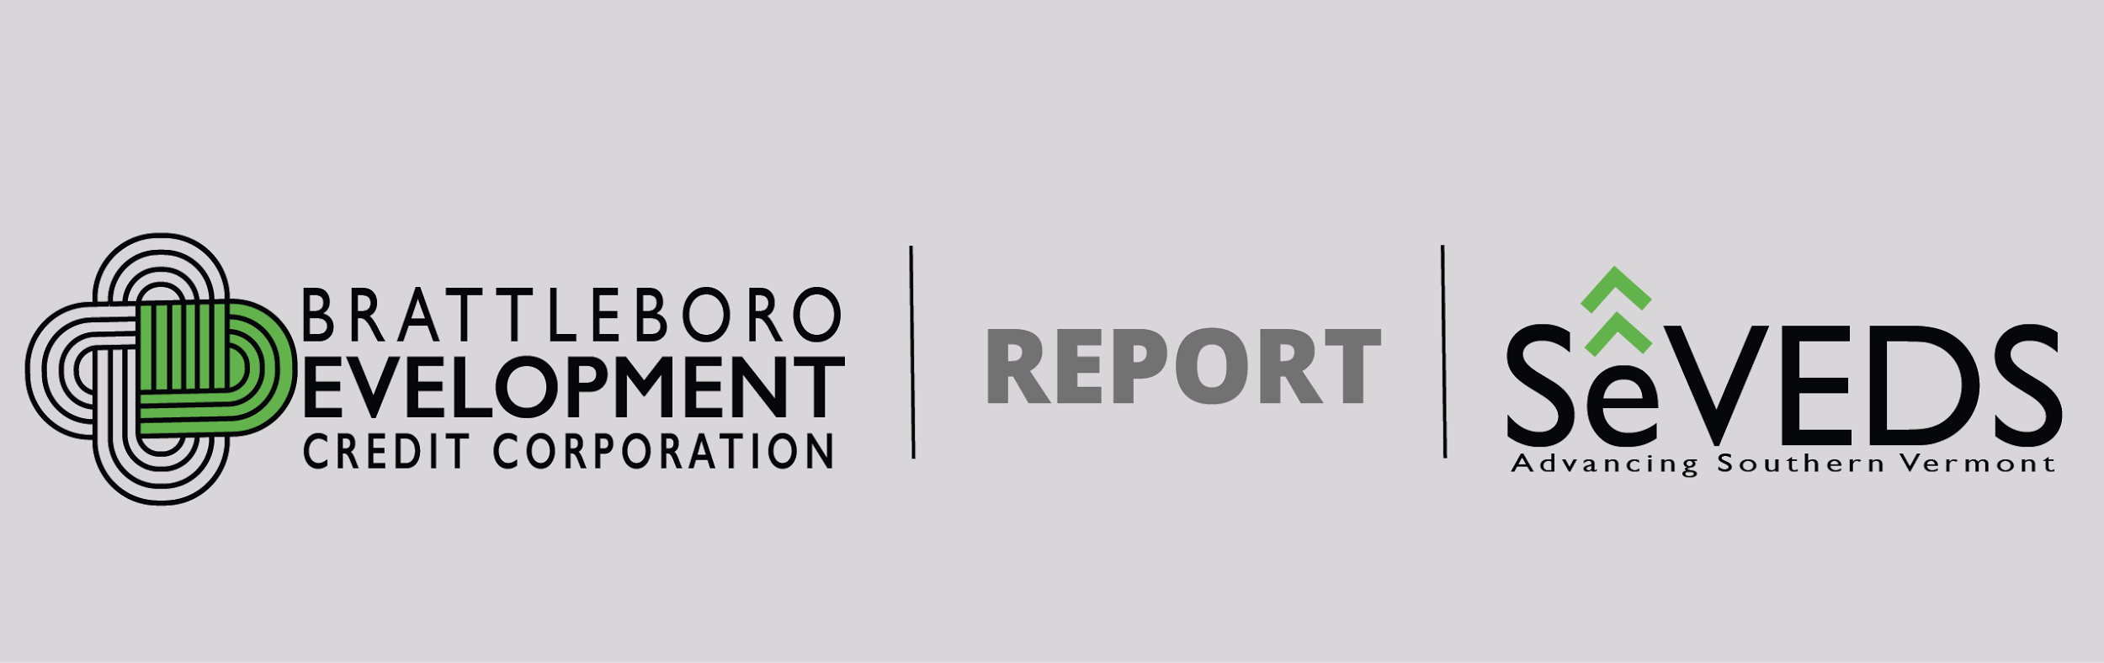

Windham Region, VT

Vermont Yankee Closure Impacts and the Role of Natural Resource-based Sectors in Economic Recovery

August 2, 2017

Policy support for proactive, effective economic development is needed to better enable recovery in rural regions impacted by nuclear power plant closure coupled with long-term economic decline. Investment in capacity, as well as targeted enhancement to improve performance in natural resource based value-added sectors can play a critical role in determining long term social and economic outcomes for affected communities.

RECOMMENDATIONS

- Language in the federal register that will support nuclear host communities across the country in preparing for, and responding to, a massive economic loss stemming from plant closure for which there is no other local, regional, state or federal support. Nuclear power plant closure leaves regional economies uniquely vulnerable, with no programs or policy to enable systemic and proactive response to offset the substantial loss of jobs, workforce, and revenue.
- Sustained commitment and investment that includes work from the “ground up” through local and regional organizations and private sector partners to develop and exploit opportunities to transform our wood product industries into a high-performing, flexible and modern sector.

FINDINGS: Vermont Yankee Nuclear Power Plant Closure Impacts

- A nuclear power plant closure is a silent storm, with hundreds of high paying jobs and hundreds of millions in annual economic impact disappearing in just a few short years. In a region such as this the underlying economic conditions are making this intense loss all the more devastating compared to locations such as Plymouth, MA or San Luis Obispo, CA. When we look at communities that lost Yankee Rowe and Wiscasset decades ago, we see steady long term decline that presages what will occur here if we do not take a proactive stance.
- A proactive stance has benefited this region. Both understanding the impact, and developing clear economic targets have been extraordinarily useful in attracting and directing resources effectively.
- The Windham S.M.A.R.T. CEDS and related planning for the VY closure, for instance, helped focus economic development on replacing 600+ highly skilled jobs paying twice area median or more, and a focus on sustaining the regional economy (GRP) through a loss of $500m annually.
- The impact of that focused investment and work can be seen already in the data: GRP is holding steady over a five year period, and wages rising due largely to growth in several firms, especially the value added food sector. By retaining and adding jobs through very specific projects and programs we are not seeing a drop in employment, in fact unemployment remains very low.
- The losses are ongoing but we are already losing funding and attention. WCEDP funds will run out, with $10m to replace losses 2-3 orders of magnitude greater than that investment each year. Language to support economic mitigation around closure may go away, despite the fact that layoffs are still ongoing at VY (20-25% this May and more coming).

FINDINGS: Rural Regional Economic Development

- Long term challenges and underlying conditions undermine the region’s economic resilience. While Irene and VY closure generated effective intervention, it took decades to get to this economically weak state and economic development intervention work has just begun. Yet sustained investment is nearly impossible to secure. This is a fundamental problem – the gap between the timeframe and investment needed and the limited duration and scale of support this region has been able to secure thus far.
- Rural Economic Development requires additional levels of support and investment to overcome lack of scale and intensity. Finding and training workforce, delivering resources to entrepreneurs, helping businesses find investment dollars and reach markets – this environment where the basic ingredients of the economy are ‘thin on the ground’ demands intensive management to produce results. Even our best and fastest growing employers are small businesses, more deeply impacted by external factors such as workforce shortages and lack of local capital.
- BDCC and partners have intensified business interventions using a variety of resources, based on the Accelerator Study completed with EDA funding last year. Already startup rates are rising measurably, reaching an all-time high in 2016, and increased activity experienced by regional business counselors, lenders, and within the entrepreneurial support we are building as part of VY Closure response.
- However, gaps in everything from capital to skills require careful and laborious work: we are building training partnerships, lending and investment tools, networks.
- There is no economic development investment in this region that is sustained, robust, or dedicated funding - either within or across sectors. This makes capacity a limiting factor requiring enormous organizational investment and risk with every initiative.
- Long term, large scale commitment to a sector would be highly effective because we can support that work now, if structured in a way that truly attracts private sector investment to bring new products and services to national and global markets.

FINDINGS: Forestry Sector and Development of Related Industries

- Based on work ongoing through the Ecovation Hub partnerships, with existing manufacturers, researchers and entrepreneurs, we have a set of identified needs to connect forest resources to markets in a way that better supports the regional and state economies.
- Startups and spinouts require comprehensive support. BDCC has built an accelerator and is now part of a network of business supports throughout the region. We secured USDA RMAP revolving loan funds to launch that program as part of a system to replace lost jobs and business activity. But we need more capacity to host the entrepreneurs, scale up, staff up, and invest at a scale that will produce major results.
- We see emerging opportunity for Windham to participate in growing markets for CLT (Cross Laminated Timber), new wood plywood products, matting, and other value-added wood products. The challenge is to develop and launch products and related services, and to connect with these new markets in a complex marketplace with building codes and demand evolving rapidly.
- To stimulate new activity requires a comprehensive framework that incentivizes production based on assured demand rather than speculative risk in an area where margins are already poor. Absent a degree of certainty, no small producer or low-margin industry can take on the risks these opportunities entail.
- There is upper level funding, but too little money on the ground with local producers. In rural region such as ours there is little at risk capital which means any new activity is leveraging small scale enterprises we can’t afford to imperil.
- Similarly, the tools we have to work with like USDA RMAP revolving loan funds help reduce risk for entrepreneurs, but BDCC instead must take the risk for those funds. The tradeoff for enforcing accountability is our tolerance for failure will reduce options for success.
- The opportunity. We have abundant natural resources, local expertise and institutions, a strong skilled workforce based, a strong manufacturing sector, and a poorly performing value-added wood manufacturing sector with tremendous room for improvement in terms of performance, profitability and scale.

TIMELINE: Cluster Development and EDA Investment in VY Closure Planning and Recovery

2010 Commonwealth Dairy breaks ground on a $32 million processing facility in Brattleboro, Vermont.
2011 State of Vermont and BDCC provide seed funding for SeVEDS effort to address impending VY closure.
2012 SeVEDS and BDCC receive $75K EDA Planning grant to develop a CEDS for Windham Region (27 towns)
2012 Commonwealth Dairy begins production.
2012 Windham region Post VY Task Force issues Report outlining the anticipated economic and job losses.
2012 BDCC takes on CDBG-DR Disaster fund management for businesses – filled critical capacity in Windham/Bennington and Windsor for overwhelmed State of Vermont after Tropical Storm Irene.
2012 Southern Vermont Disaster Recovery from EDA partnership grant with BDCC, Windham Regional Commission and Bennington County Regional Commission (470K).
2013 $12 million expansion at Commonwealth Dairy (23,000 sf added to original 39,000 sf) and increasing the workforce at the facility from 110 to over 140.
2014 EDA attends VT State tourism conference featuring disaster funded So Vermont Sustainable Marketing Program.
2014 The region’s first economic plan, the Windham S.M.A.R.T. CEDS, accepted by EDA.
2014 Windham workforce inventory completed – showed employer need for replacement or new employees over 3500 through 2019. Used as basis to develop BDCC-SeVEDS Workforce Center of Excellence to respond.
2014 10 million dollars for Windham Region Economic Development from State of Vermont/Entergy Nuclear Power Plant settlement Based on Post VY Task Force report – establishes “WCEDP” program and funding which provides direct grants and loans, and business development capacity at BDCC.
2014 UMass Donahue Institute three state impact study on VY Closure identifies $500 million in annual losses.
2015 EDA grant received for Cluster Analysis, Accelerator Feasibility, Tri-State CEDS alignment ($267k), with WCEDP match.
2016 Tri-State CEDS Comparison Completed, Green Building Cluster Analysis Completed.
2016 Southern Vermont Accelerator Feasibility Completed and used to implement pre-accelerator programming and business development (INSTIG8, 802Cups, Acceler8).
2016 IEDC (International Economic Development Council) Award for implementing a Multi-Year Economic Development Program (Windham S.M.A.R.T. CEDS).
2016 EDA attends National Release White Paper on Nuclear Host Communities in Brattleboro.
2016 Commonwealth announces $2 million expansion, relocating administrative offices in the production facility and relocating administration to new global headquarters building to add more production capacity in existing plant. $1 million in public funding from VY Closure WCEDP funds.
2017 EDA notifies BDCC no longer qualifies for programs based on nuclear power plant closure.
2017 Green Building Cluster Independent Leadership Team launched with initial projects.
2017 Tri-State Green Economy Knowledge Consortium 4 college MOU signed for workforce training.
2017 Financing the working Land Conference being planned for Windham Region.

