Southern Vermont Comprehensive Economic Development Strategy: Economic Profile

June 2018

Prepared for:

Brattleboro Development Credit Corporation

76 Cotton Mill Hill  
Brattleboro, VT 05301



**120 West Avenue, Suite 303**Saratoga Springs, NY 12866

518.899.2608

www.camoinassociates.com

About Camoin Associates

Camoin Associates has provided economic development consulting services to municipalities, economic development agencies, and private enterprises since 1999. Through the services offered, Camoin Associates has had the opportunity to serve EDOs and local and state governments from Maine to California; corporations and organizations that include Lowes Home Improvement, FedEx, Volvo (Nova Bus) and the New York Islanders; as well as private developers proposing projects in excess of $6 billion. Our reputation for detailed, place-specific, and accurate analysis has led to projects in 31 states and garnered attention from national media outlets including *Marketplace* (NPR), *Forbes* magazine, *The New York Times* and *The Wall Street Journal*. Additionally, our marketing strategies have helped our clients gain both national and local media coverage for their projects in order to build public support and leverage additional funding. We are based in Saratoga Springs, NY, with regional offices in Portland, ME; Boston, MA; Richmond, VA and Brattleboro, VT. To learn more about our experience and projects in all of our service lines, please visit our website at [www.camoinassociates.com](http://www.camoinassociates.com). You can also find us on Twitter [@camoinassociate](https://twitter.com/CamoinAssociate) and on [Facebook](https://www.facebook.com/camoinassociates).

The Project Team

Rachel Selsky

*Principal & Project Manager*

Bethany Meys

*Project Staff*

Mark Waterhouse, Senior Advisor

*Garnet Consulting Services, Inc.*

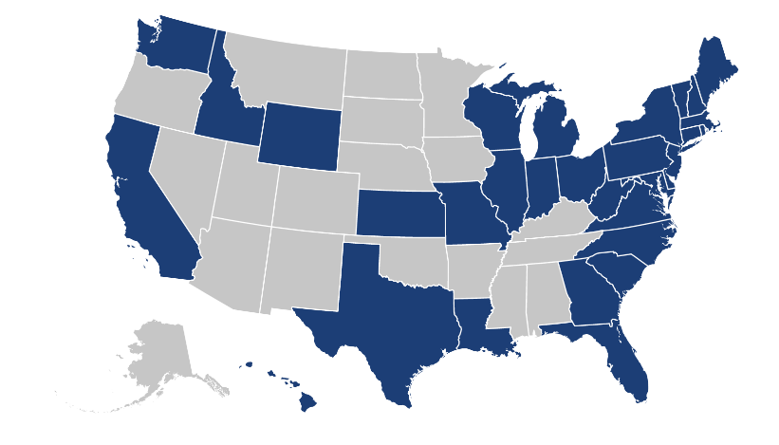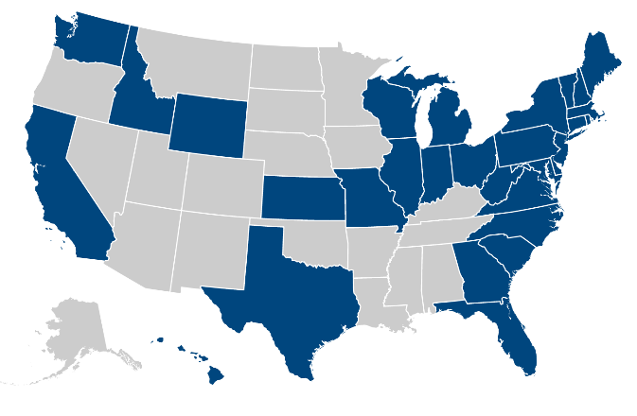

Table of Contents

Executive Summary 1

Introduction 3

Socioeconomic Analysis 4

Economic Profile 7

Conclusions 21

Attachment A: Data Sources 22



# Executive Summary

The Southern Vermont Economic Development Zone, comprised of Bennington and Windham Counties (referred to as the “Zone”), is undertaking a Comprehensive Economic Development Strategy (CEDS). As part of the CEDS process, the first step is to collect basic economic data to understand the existing conditions in the Zone from which the plan will be based. This economic base analysis considers the Zone and compares it to other study area regions, including neighboring counties, the State of Vermont, and the Vermont, Massachusetts, New Hampshire, and New York region. By comparing these regions, we can more easily identify areas of strength and weakness in the Zone and potential emerging opportunities.

The following are some key findings from the economic base analysis, and what these findings mean for economic development and workforce development in the Zone.

* **The population of the Zone is getting smaller and older at a rate faster than the comparison geographies.** This demographic trend is one that is well-known and reported but it is crucial to consider when creating an economic development strategy as it puts considerable strain on the Zone’s ability to attract and retain companies and other employers. With employees aging out of the workforce, business owners looking to retire, and a shrinking labor pool, companies are experiencing significant challenges when it comes to finding the right employees with necessary skills. Limited workforce availability constraining growth is occurring in nearly all industries with more significant challenges in some of the largest industries in the region, including Health Care and Manufacturing.

The trend of an aging and declining population is not unique to Southern Vermont, many communities throughout New England are struggling with similar challenges. Nevertheless, a successful economic development strategy will need to consider ways to attract and retain a younger population to create an adequate pipeline of workers for employers to remain and expand in the area. In addition, strategies to retain older workers in the workforce for a longer period are also needed.

* **The median household income in the Zone is just under $52,000 and is only projected to grow by 7% over the next five years**, compared to much higher income levels and faster growth in the other study areas. The median household income in the United States is just above to $59,000 and projected to grow by 11% over the next five years. Lower income levels impact the ability for residents to participate in the local economy, buy and maintain homes, have reliable transportation, access health care, and purchase other goods and services that support sustainable and vibrant economies.

The wages employers can offer their employees is dependent on several factors; however, there are proactive measures that can be included in the economic development strategy that will work to increase the overall median household income. These strategies should focus on: increasing training available for the existing workforce so they can earn higher wages; looking to attract and retain high-quality and high-earning jobs; and establishing support systems for people to have the opportunity to participate in the workforce through transportation, child care, and other initiatives.

* **The Health Care industry is the largest industry by current number of jobs and projected to continue to grow.** Major employers in the Zone include Southwest Vermont Medical Center, the Brattleboro Retreat, and Brattleboro Memorial Hospital; these employers and the Health Care industry as a whole play a significant role in the regional economy. With a range of employment opportunities at these facilities, from nurses to surgeons and cashiers to managers, health care provides a significant source of employment and potential career pathways for many employees.

Health care is important to the local economy for a number of reasons, not only is it a large source of jobs but residents having a variety of quality health care providers is vital for attraction and retention. Health care is an indicator of quality of life and many people looking to relocate will consider the variety, quality, and reputation of the health care providers in a new area to ensure it will work to serve their families. Finding ways to support the workforce pipeline for this industry is crucial to expanding existing capacity and easing some of the constraints on the industry’s ability to provide high quality care.

* **Tourism is a critical industry cluster for Southern Vermont.** This cluster in Southern Vermont is made up of industries including Accommodation and Food Services (5,390 jobs[1]), Retail Trade (5,376 jobs), and Arts, Entertainment, and Recreation (880 jobs). Earnings in this industry cluster are lower than the average, with average earnings ranging from $27,000 to $37,000 compared to the average earnings across all industries at $49,5000. This industry cluster also has high levels of seasonality.

The tourism cluster for Southern Vermont is important not only because it drives economic activity from people visiting the area and bringing money in, it also serves to improve the quality of life for those that live here and can be a recruitment tool. Having high quality places, nightlife, cultural amenities, recreation resources, and other assets that are attractive to visitors also make it a great place to live. While the sectors serving visitors are crucial to Southern Vermont employment, it is just as important to support those sub-sectors to create high quality places for residents. Strategies to serve the tourism industry should continue to look for ways to increase the length of the season, apply innovative approaches to marketing (including converting visitor attraction into new permanent residents), find ways for employees to have year-round work, and help businesses remain flexible to the changing trends of tourism.

* **The fifth largest industry in Southern Vermont Zone is Manufacturing, with just over 4,700 jobs in 2017.** With high paying and stable work, the Manufacturing industry can continue to be a stable source of employment for many workers in the region. Within the Manufacturing industry, the largest subsector is Plastics Product Manufacturing (572 jobs).

Top industries within the manufacturing sector cover a range of sectors from plastics, motor vehicles, paper, dairy, and food products. The Plastics Product Manufacturing subsector is projected to grow 3% from 2017 to 2023 adding 15 jobs. Pulp, Paper, and Paperboard Mills is the most highly concentrated subsector in the Zone with a location quotient of 11.53. Within value added food production sectors, the top industries, by number of jobs, include Commercial Bakeries (164 jobs 7), Fluid Milk Manufacturing (189 jobs), Cheese Manufacturing (71 jobs), and Frozen Specialty Food Manufacturing (70 jobs).

Overall, the data analyzed throughout this report gives a basic understanding of the existing conditions in the Southern Vermont Zone and beyond, but does not capture the emerging opportunities that are made possible due to the unique energy and vision of the residents around particular niche industries. In a place like Southern Vermont and in the current regional and national economy, it is not going to be one or two major employers coming to town that will “fix everything”, but rather a concerted effort by multiple different industry partners to innovate, be nimble, find solutions, and get creative in order to be sustainable and adaptable.

# Introduction

As part of the Southern Vermont Comprehensive Economic Development Strategy (CEDS), historic, current, and projected economic conditions were analyzed to inform where the Southern Vermont Economic Development Zone has been, where the Zone is currently, and anticipated trends that will impact future progress and development. Information presented in this document includes an overview of socioeconomic, demographic, industry, and occupational trends.

## Geographies Studied

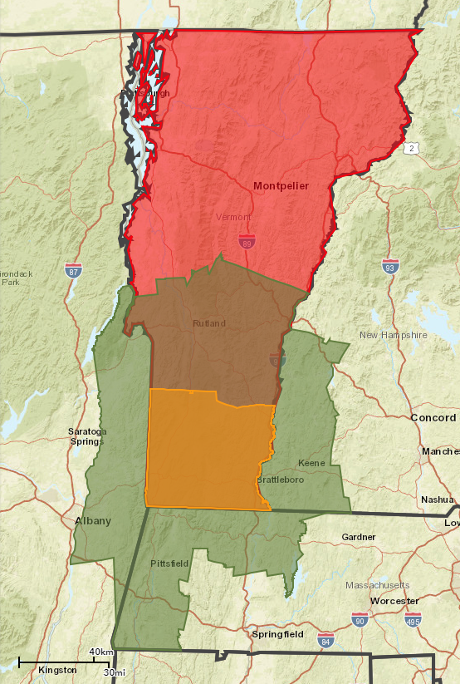

Figure 1: Map of Vermont, Reference Region and Southern Vermont Zone

**Reference Region**

**Southern  
Vermont Zone**

*Source: Esri*

**Vermont**

### Southern Vermont Zone

The Southern Vermont Economic Development Zone (referred to herein as the Southern Vermont Zone, the Zone or SoVT Zone) is defined as the area contained within Bennington County, VT and Windham County, VT.

### Reference Region

The Reference Region includes the counties within the Zone as well as neighboring counties. The Reference Region is comprised of the following counties: Berkshire, MA; Franklin, MA; Cheshire, NH; Sullivan, NH; Rensselaer, NY; Washington, NY; Bennington, VT; Rutland, VT; Windham, VT; and Windsor, VT.

### Vermont

The state of Vermont was used as a benchmark for the Southern Vermont Zone.

### 4-State Region

The 4-State Region includes Vermont, as well as its three neighboring states New York, New Hampshire and Massachusetts.

# Socioeconomic Analysis

As of 2016, there were approximately 80,000 people living within the Zone. The population has decreased since 2010, and is projected to continue decreasing until 2030 for a total decline of 3.7% from 2010 to 2030. In 2016, the State of Vermont had a population of 626,000 and is projected to decline to 620,000 by 2030. Conversely, the Reference Region and 4-State Region are projected to grow their population bases into 2030.

Table 1: Population by Study Region, 2000 - 2030



### Age

Overall, SoVT Zone residents are older than the residents of the other study regions. As shown in Table 2, the median age in the Zone is 47 compared to 44.6 within the Reference Region and 43.1 within the state. The Zone has been increasing in median age at a faster rate compared to the other geographies and is projected to increase by 2.6% to 48.2 by 2022.

Table 2: Median Age by Study Region, 2010 - 2022



Figure 2 below, shows that the age distribution of the Zone skews more heavily towards the older age cohorts compared to the other study regions. The Zone has the highest percentage of individuals in the age cohorts above the age of 45 compared to the Reference Region, Vermont, and the 4-State Region. Conversely, the 4-State Region, with the lowest median age, leads in nearly all but one age cohort under the age of 44.

Figure 2: Population Distribution by Age Cohort by Study Region, 2017

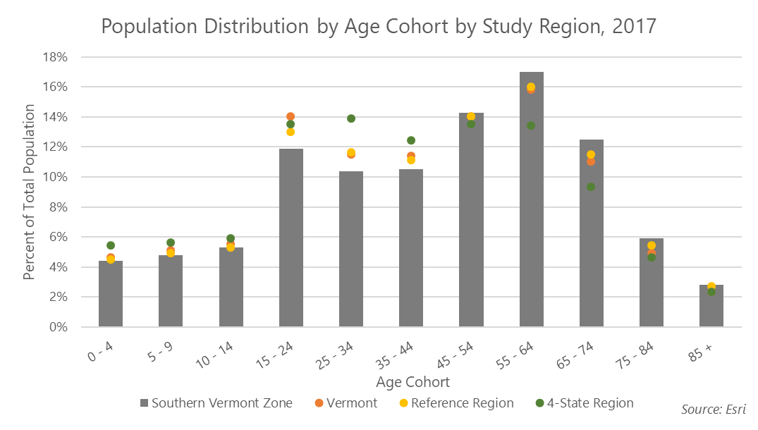

### Income

The Zone has the lowest median household income of the four study regions with a median household income of $52,000. The median household income of the Zone is projected to increase by 6.9% to $55,500 by 2022. All other study regions are projected to experience stronger growth over the 2017 to 2022 period.

Table 3: Median Household Income by Study Region, 2017 - 2022



Figure 3 shows income distribution by income cohort for each study region. Roughly a third of Zone households earn less than $34,999.

Figure 3: Distribution of Income by Study Region, 2017

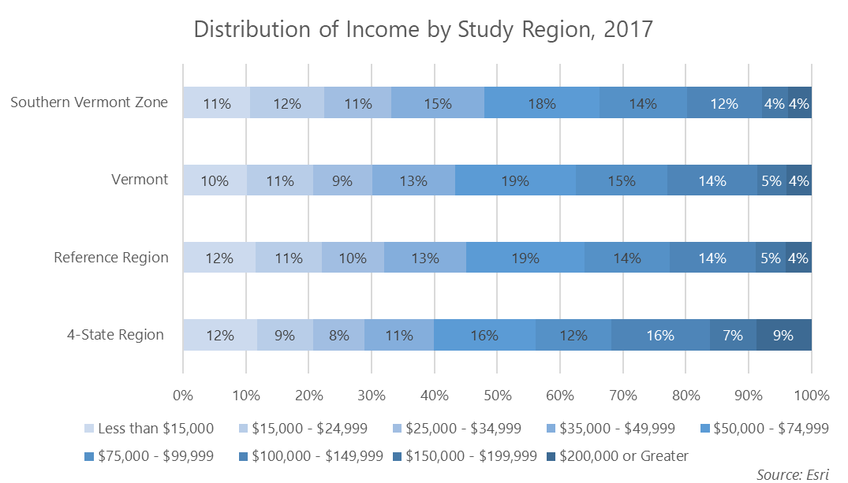

### Educational Attainment

As of 2017, 92% of Zone residents age 25+ had achieved a high school education or greatercompared to the Reference Region (92%), Vermont (92%) and 4-State Region (88%).

Figure 4: Educational Attainment by Study Region, 2017

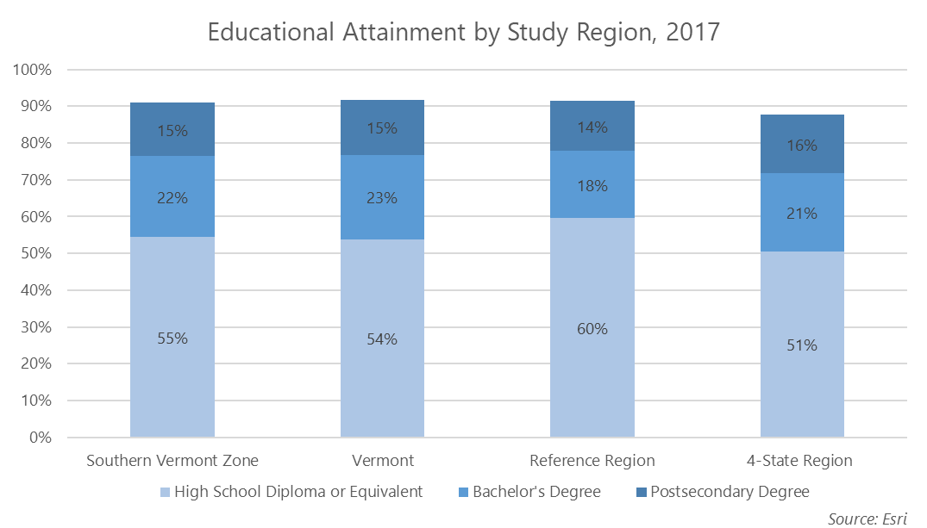

# Economic Profile

The Economic Profile consists of an analysis of employment trends and characteristics from 2013 to 2023, occupational analysis, and location quotient analysis of the Southern Vermont Zone.

Industries are displayed using the North American Industry Classification System (NAICS) at the 2-Digit and 4-Digit levels. Occupations are displayed using Standard Occupational Classification (SOC) codes at the highest level, the 6-Digit level, to provide the most detailed results.

### Key Findings:

* The Southern Vermont Zone holds approximately 46,000 of Vermont’s 358,000 jobs or 12%.
* Job growth in the SoVTZone is projected to occur at a slower rate than the surrounding areas, expanding 1% from 2017 to 2023 compared to a 2% growth in the Reference Region, 3% growth in Vermont, and 6% within the 4-State Region.
* Compared to the other study regions, Southern Vermont has the lowest average earnings per jobs at approximately $48,000.
* At the 2-Digit Level, Government and Health Care and Social Assistance rank as top two industries by number of 2017 jobs within the study regions.
* Half of Southern Vermont’s top 20, 4-Digit industries in terms of 2017 jobs are projected to decline in number of jobs from 2017 to 2023.
* The top 6-Digit occupations in the SoVT Zone support a variety of educational attainment levels and provide an array of on-the-job training. Additionally, the vast majority of top occupations do not require previous work experience.
* At the 2-Digit level, the majority of industries in the SoVT Zone are projected to decline in terms of jobs from 2013 to 2023. Only two industries show positive job growth and location quotients (LQ)[2] greater than 1.20: Educational Services and Accommodation and Food Services.
* 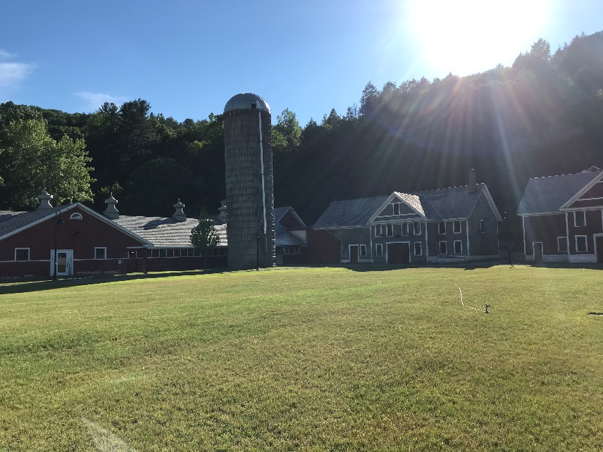Three of the SoVT Zone’s top 20 industries by 2017 jobs are within the Health Care and Social Assistance industry, including Psychiatric and Substance Abuse Hospitals, General Medical and Surgical Hospitals, and Outpatient Care Centers. These 4-Digit industries are also highly concentrated with LQs above 1.20. Of particular note, Psychiatric and Substance Abuse Hospitals is highly concentrated with a 2017 LQ of 21.52.

### Southern Vermont Economic Development Zone

As of 2017, the Zone had approximately 46,000 jobs. The total number of jobs declined slightly, by 1% from 2013 to 2017, but is projected to increase by 1% in the years from 2017 to 2023. Largest industry sectors by 2017 job counts are Health Care and Social Assistance (6,734 jobs), Government (5,740), Accommodations and Food Services (5,390), and Retail Trade (5,376). Looking forward to 2023, these industries are projected to grow and remain the top three 2-Digit industries in the SoVT Zone.

As shown in Table 4, average earnings for all jobs within the SoVT Zone is $48,000. The industry with the highest average earnings per job is Utilities with average earnings of $191,000. However, this industry has experienced sharp job decline of 77% from 2012 to 2017 (related to the closure of the Vermont Yankee Nuclear Facility). Other industries with notable earnings include Mining, Quarrying, and Oil and Gas Extraction and Management of Companies and Enterprises with average earnings of $120,000 and $95,000 respectively. Both of these industries have grown since 2013 and are projected to continue to grow.

Table 4: Southern Vermont Zone Total Jobs, 2013 – 2023



Table 5 examines the top 20 industries in the Southern Vermont Zone at the 4-Digit NAICS Level, which provides a more granular view of exactly which industries were most common in the Southern Vermont economy in 2017. Top industries at the 4-Digit level include Education and Hospitals (Local Government), Traveler Accommodations and Restaurants and Other Eating Places securing the top industries by number of jobs with 2,800; 2,500; and 2,400 jobs respectively. These industries are projected to remain the top three industries in 2023. Of particular note, half of the top 20 industries are projected to decline by 2023.

Table 5: Southern Vermont Zone Top Jobs by 2017 Job Count, 2013 - 2023



Table 6 displays the top 20 occupations by SOC within the Southern Vermont Zone by 2017 job counts. Cashiers and Retail Salespersons rank among the largest occupations with 1,300 and 1,200 jobs respectively. Although these industries are projected to remain on top into 2023, they are both projected to decline by number of positions. Eleven out the top 20 occupations are projected to decline into 2023.

Health Care related occupations including Personal Care Aides and Registered Nurses are projected to experience the largest growth (by percentage but not by actual job count) from 2017 to 2023. Personal Care Aides are projected to grow by 51 jobs by 2023, growing by 10%. Registered Nurses are projected to increase by 69 jobs, growing by 9%, by 2023. Additionally, Registered Nurses have the highest average hourly earnings of the top 20 occupations, earning $30.93 per hour.

Typical entry level education among the top occupations includes a wide range, from no formal education to bachelor’s degrees, and certificate awards. Thirteen of the top occupations have a typical entry education of no formal education to which school diploma or equivalent while only three occupations require a Bachelor’s degree. All top occupations do not require work experience, except for First-Line Supervisors of Retail Sales Workers which requires less than five years of work experience. Typical on-the job training for these top occupations ranges from none, to short and moderate term on the job training and apprenticeships.

Table 6: Southern Vermont Zone Top 20 Occupations by 2017 Job Count, 2017 - 2023



##### Location Quotient

Location Quotient (LQ) analysis compares a specific geographic region to a larger reference area by quantifying the concentration of an industry, demographic group, or other variable compared to its concentration in the larger geography. The concentration of employment by industry in the Southern Vermont Zone is compared to the nation to identify which industries are highly concentrated and, therefore, may have a competitive advantage within the Zone.

LQ is calculated by dividing the percent of jobs within each industry locally by the percent of jobs in the same industry at the national level. For example, if the finance and insurance industry accounts for 2% of jobs in a community and at the national level this industry has 1% of the total jobs, the community has a LQ of 2.0 (0.02 ÷ 0.01 = 2). In this example, the local community employs twice as many individuals in the industry as expected based on national employment patterns. Typically, only values above 1.20 or below 0.80 are considered “significant” findings in LQ analysis. Industries with a high LQ and high employment numbers are assumed to produce more than what is needed locally (i.e. a surplus) and export their products and services.

Figure 6 displays 2-Digit NAICS industries in the Southern Vermont Zone by 2017 location quotient and job growth between 2013 and 2023. The majority of 2-Digit industries have location quotients below 1.20, indicating they are not highly concentrated in the Zone. Additionally, the majority of the 2-Digit industries show negative job growth as displayed on the left side of the y-axis.

Educational Services has the highest location quotient at 3.10, and shows positive job growth of 6%. Another industry with an LQ above 1.20 is Accommodation and Food Services with an LQ of 1.38 and a 15% job growth from 2013 to 2023. Management of Companies shows the highest job growth at 36% and a location quotient of 0.43, indicating it is not highly concentrated.

Figure 5: Industries by 2013 - 2023 Job Growth and Current Location Quotient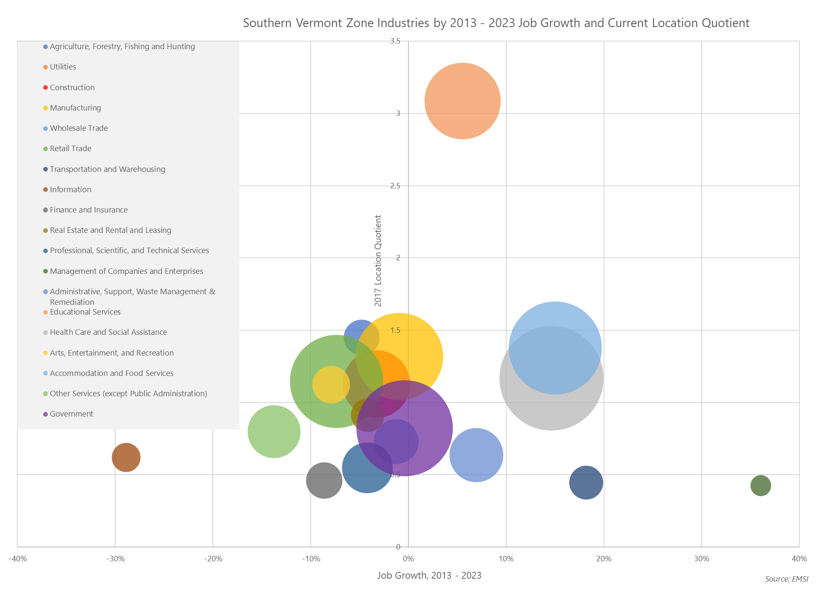

Table 7 below shows the top 20, 4-Digit NAICS industries in the Southern Vermont Zone by 2017 job count. Industries with location quotients greater than 1.20, indicating highly concentrated industries, have been highlighted in orange.

Thirteen of the top 20 industries by 2017 job count have LQs greater than 1.20. Although many of the concentrated industries are projected to shed jobs from 2017 to 2023, they will remain concentrated compared to national levels. As of 2017, Traveler Accommodation; Colleges, Universities, and Professional Schools; and General Medical and Surgical Hospitals industries are the top three industries by employment numbers and have LQs above 1.20. Psychiatric and Substance Abuse Hospitals is highly concentrated with an LQ of 21.52 for 2017, and projected to rise to 22.75 by 2023. Also within the Health Care and Social Assistance industry there are two other major subsectors that show strong growth and LQs greater than 1.20: General Medical and Surgical Hospitals (LQ 1.33) and Outpatient Care Centers (LQ 1.95).

Table 7: Southern Vermont Zone Top 30 Concentrated Industries by 2017 Job Count, 2017 - 2023



### Vermont

Table 8 shows that from 2013 to 2017, Vermont grew from approximately 352,000 jobs to over 358,000, showing 2% growth. From 2017 to 2023, the state is projected to gain an additional 11,600 jobs for a growth rate of 3%. Industries with the highest number of jobs include Government (60,638 jobs), Health Care and Social Assistance (56,416), and Retail Trade (39,555). Each of these industries is projected to grow and remain the top three industries by number of jobs by 2023. Vermont average earnings per job is approximately $54,000. Similar to the Southern Vermont Zone, Utilities has the highest average earnings in Vermont at $139,000 per job.

Table 8: Vermont Total Jobs, 2013 - 2023



As shown in Table 9, although declining in number of jobs, the Education and Hospitals (Local Government) industry remains the top 4-Digit industry in terms of 2017 jobs. Restaurants and Other Eating Places and General Medical and Surgical Hospitals are also among top industries with approximately 18,000 and 13,000 jobs each. Within the health care sector, Outpatient Care Centers are projected to grow by 23%, adding more than 1,100 jobs from 2017 to 2023. Additionally, Computer Systems Design and Related Services is projected to have substantial growth, growing by 14% by 2023. The Computer Systems Design and Related Services industry has exceptionally high average earnings at over $100,000 per job. This is the third highest earnings behind Offices of Physicians ($107,000) and Federal Government, Civilian ($104,000).

Table 9: Vermont Top Jobs by 2017 Job Count, 2013 - 2023



Occupations in Table 10 below are examined using SOC codes. As of 2017, the top occupations within Vermont were Cashiers (9,659 jobs), Retail Salespersons (9,067 jobs), and Personal Care Aides (8,377 jobs). These occupations are projected to grow minimally into 2023 and remain the top occupations for 2023. The occupation projected to experience the largest growth is Registered Nurses, with a projected growth rate of 11%, adding 671 positions by 2023. Registered Nurses typically require a Bachelor’s degree. None of the top occupations require work experience and occupations provide an array of on-the-job training ranging from none, to short- and moderate-term, to apprenticeships.

Table 10: Vermont Top 20 Occupations by 2017 Job Count, 2017 - 2023



### Reference Region

Table 11 shows that as of 2017, there were approximately 333,000 jobs within the Reference Region. A significant portion of those jobs were allocated to the top industries of Government (55,579 jobs), Health Care and Social Assistance (49,634), and Retail Trade (39,211). Within the region, the industries projected to experience the greatest growth are Utilities, growing by 10% from 1,800 jobs in 2017 to 2,000 jobs in 2023, and Health Care and Social Assistance growing by 8% from 50,000 jobs to 53,000.

Within the Reference Region, average earnings per job were approximately $53,000. Similar to the SoVT Zone, Utilities and Management of Companies and Enterprises were among the highest earning industries with average earnings of $156,000 and $103,000 respectively.

Table 11: Reference Region Total Jobs, 2013 - 2023



Table 12 shows that at the 4-Digit NAICS code level Education and Hospitals (Local Government) is the top industry with approximately 24,000 jobs in 2017. Restaurants and Other Eating Places and Local Government, Excluding Education and Hospitals also are among top industries with 19,000 and 14,000 jobs respectively. The importance of local government employment (combining the general government and local government education and hospitals sectors) is obvious.

Within the Reference Region, seven of the top 20 industries are projected to decline from 2017 to 2023. Industries under the Health Care and Social Assistance 2-Digit industry are projected to experience the highest rate of growth with Individual and Family Services and Residential Intellectual and Developmental Disability, Mental Health, and Substance Abuse Facilities adding 683 (12%) and 516 (15%) jobs.

Table 12: Reference Region Top Jobs by 2017 Job Count, 2013 - 2023



Table 13 shows that service industry positions comprise the top occupations within the Reference Region. Retail Salespersons, Cashiers, and Combined Food Preparation and Serving Workers, Including Fast Food are the top occupations with 9,300, 9,100, and 6,200 jobs. These jobs have relatively low average hourly earnings, have no educational and work experience requirement and provide short term job training. The top occupation projected to grow the greatest amount into 2023 is Personal Care Aides, with a 13% growth.

Within the Reference Region, top occupations with higher average earnings are associated with a higher entry level education. The highest earning occupation is General and Operations Managers earning an average of $54.40 an hour. This position has a typical entry level education of a Bachelor's degree and five years of experience. Postsecondary Teachers also have notable average hourly earnings at $40.74. This position is projected to experience an 8% growth into 2023, adding 335 positions.

Table 13: Reference Region Top 20 Occupations by 2017 Job Count, 2017 - 2023



### 4-State Region

Table 14 shows that of all study regions, job growth is the highest in the 4-State Region, growing 6% from 2013 to 2017 and an additional 6% by 2023. The largest industries include Health Care and Social Assistance and Government which employ 2.4 million and 2.1 million, respectively.

Average earnings are relatively high at $79,000 per job. Finance and Insurance has the highest average earnings per job at approximately $223,000, followed by Utilities with $163,000 and Management of Companies and Corporations with $159,000.

Table 14: 4-State Region Top Jobs by 2017 Job Count, 2013 to 2023



Table 15 below lists the top 20, 4-Digit industries for the 4-State Region. Few top industries at the 4-Digit level are projected to decline into 2023: State Government, Excluding Education and Hospitals and Legal Services are projected to decline minimally by less than 1%, while Federal Government, Civilian is projected to decline by 8% into 2023. Home and Health Care Services is projected to grow 42%, adding over 108,000 jobs by 2023. Additionally, Education and Hospitals (Local Government) and Restaurants and Other Eating Places are projected to grow by 92,000 and 86,000 jobs respectively.

Table 15: 4-State Region Top Jobs by 2017 Job Count, 2013 - 2023



Table 16 displays the top 20 occupations in the 4-State Region. From 2017 to 2023, Home Health Aides are projected to experience the largest growth, adding an additional 50,000 occupations for a growth rate of 21%. Similarly, Personal Care Aides are projected to grow by 17% adding an additional 50,000 jobs by 2023. Both of these occupations have relatively low earnings of approximately $12 and require a high school diploma or equivalent and no work experience.

Within the 4-State Region, General and Operations Managers have the highest average hourly earnings at $68.19 an hour. Postsecondary Teachers and Accountants and Auditors also have notable earnings at $46.77 and $42.39 respectively.

Table 16: 4-State Region Top 20 Occupations by 2017 Job Count, 2017 - 2023



# Conclusions

Southern Vermont is facing some real demographic related challenges including an aging and declining population that will impact economic and community development. These trends are not surprising as they were a focus of the 2014 Windham County CEDS, but they remain an issue when preparing the Southern Vermont Zone CEDS.

The industries that are showing any real gains in employment over the next five years in the Southern Vermont Zone include Accommodation and Food Services, and Health Care and Social Assistance and these employment increases are in line with the other study areas. At the high-level industry classification of 2-digit NAICS, all other industries are remaining stable or losing employment in Southern Vermont. However, when looking closer at the industries that are losing employment, there are sub-sectors that are gaining that may prove to be opportunities for continued growth. For example, within the Manufacturing industry, there are sub sectors that are showing growth such as the precision manufacturing cluster and the value added food product manufacturing cluster.

One thing that is not captured in this data is the unique ability of the Southern Vermont economy to face challenges with reinvention and resilience. The economic data that is presented in this analysis will be coupled with the qualitative information from the interviews, focus groups, and economic summit conducted as part of preparing this CEDS. This information is expected to demonstrate the Southern Vermont Zone’s resilience and emerging opportunities and identify key sectors and clusters for future focus, This information will also help regional stakeholders and residents to better integrate the numbers with the realities of the people “on-the-ground”.

# Attachment A: Data Sources

## Proprietary Data Sources

### Economic Modeling Specialists International (EMSI)

To analyze the industrial makeup of a study area, industry data organized by the North American Industrial Classification System (NAICS) is assessed. Camoin Associates subscribes to Economic Modeling Specialists Intl. (EMSI), a proprietary data provider that aggregates economic data from approximately 90 sources. EMSI industry data, in our experience, is more complete than most or perhaps all local data sources (for more information on EMSI, please see [www.economicmodeling.com](http://www.economicmodeling.com)). This is because local data sources typically miss significant employment counts by industry because data on sole proprietorships and contractual employment (i.e. 1099 contractor positions) is not included and because certain employment counts are suppressed from BLS/BEA figures for confidentiality reasons when too few establishments exist within a single NAICS code.

### ESRI Business Analyst Online (BAO)

ESRI is the leading provider of location-driven market insights. It combines demographic, lifestyle, and spending data with map-based analytics to provide market intelligence for strategic decision-making. ESRI uses proprietary statistical models and data from the U.S. Census Bureau, the U.S. Postal Service, and various other sources to present current conditions and project future trends. Esri data are used by developers to maximize their portfolio, retailers to understand growth opportunities, and by economic developers to attract business that fits their community. For more information, visit [www.esri.com](http://www.esri.com).

## Public Data Sources

### American Community Survey (ACS), U.S. Census

The American Community Survey (ACS) is an ongoing statistical survey by the U.S. Census Bureau that gathers demographic and socioeconomic information on age, sex, race, family and relationships, income and benefits, health insurance, education, veteran status, disabilities, commute patterns, and other topics. The survey is mandatory to fill out, but the survey is only sent to a small sample of the population on a rotating basis. The survey is crucial to major planning decisions, like vital services and infrastructure investments, made by municipalities and cities. The questions on the ACS are different than those asked on the decennial census and provide ongoing demographic updates of the nation down to the block group level. For more information on the ACS, visit <http://www.census.gov/programs-surveys/acs/>.



**Camoin logo.tifCamoin Associates, Inc.**  
120 West Avenue, Suite 303  
Saratoga Springs, NY 12866

518.899.2608  
www.camoinassociates.com  
@camoinassociate

1. Jobs estimates listed are sourced from EMSI and indicate the number of jobs in Southern Vermont from 2017.
2. Location Quotients measure the concentration of a given industry in a specific region relative to the United States. An LQ above 1.20 is considered significant.